**Dumpit(Scarp Management System)**

**A Project Report**

Submitted in partial fulfilment of the

Requirements for the award of the degree of

**BACHELOR OF SCIENCE (COMPUTER SCIENCE)**

**BY**

**Deepak Rajender Prasad Verma**

7625

Under the guidance of **MR. aBHIJEET SALVI.**



**DEPARTMENT OFINFORMATION TECHNOLOGY**

**PILLAI’S COLLEGE OF ARTS , COMMERCE & SCIENCE**

**Autonomous**

**(Affiliated to University Of Mumbai)**

**NEW PANVEL – 410 206**

**MAHARASHTRA**

**Academic Year 2019– 20**

1. **ACKNOWLEDGEMENT**

I Mister. Deepak Verma student of PILLAI COLLEGE OF ARTS,COMMERCE & SCIENCE, NEW PANVEL would like to express mysincere gratitude towards Computer Science Department.

I would like to thank Mrs. Mrs. Shubhangi Pawar H.O.D. (I.T. & C.S.) forgranting me the opportunity to build project for the college. Last but notleast I thank Lect. Mr. Abhijeet Salvi for their constant support during the project.

The project would not have been completed without dedication, creativityand energy which my family provided.

Yours faithfully,

Deepak Rajender Prasad Verma

(Final Year Computer Science)

1. **PRELIMINARYINVESTIGATION**

**Organizational overview:**

Pillai College of Arts, Commerce and Science (PCACS) was established in 1998By Dr. K. M. Vasudevan Pillai, Chairman and CEO, MES whose vision was toProvide students of Navi Mumbai with quality education in a high-tech

Atmosphere.

PCACS provides many services to its students via its website like academic

Calendar, ATKT registration, railway concession forms, etc. Yet, few other

Services are still offline for the students.

The project- “student information management” is undertaken by me, as an

Initiative (in collaboration and support of PCACS management) to provide fewMore major online services to the students

1. **Description of System**

**1.Problem Facing Now**

A large amount of [solid waste](https://www.omicsonline.org/open-access/isolation-screening-and-characterization-of-cellulase-producing-bacterialisolates-from-municipal-solid-wastes-and-rice-straw-waste-2155-9821-1000280.php?aid=72626) that is being generated by the Municipality, such as markets, is left generally unmanaged. The waste collection and disposal does not contend with the amount of waste generated per day as a result garbage are scattered. Market areas produce not only a large quantity of solid waste but also generate different types of waste. Because the market areas generate different types of waste, they need to be managed properly in order to avoid the detrimental effects it could have on the environment, health, and [ecosystem](https://www.omicsonline.org/open-access/ecosystem-approach-based-methodology-to-support-land-use-planningegyptian-experience-2155-9910-1000201.php?aid=76569). This paper will therefore present the challenges and problem associated with managing the [solid waste](https://www.omicsonline.org/open-access/solid-waste-disposal-and-community-health-implications-in-ghanaevidence-from-sawaba-asokore-mampong-municipal-assembly-2165-784X-1000202.php?aid=67082) generated by the three main markets (Mwanakwerekwe, Darajani and Mikunguni) which make up the Zanzibar municipality. Several methods were used to conduct this study including questionnaires, interviews and direct observations. The results of the study showed that the daily amount of solid waste generated by Mwanakwerekwe, Darajani and Mikunguni were 9,296 kg per day, 4,648 kg per day and 830 kg per day, respectively. The study also revealed several shortcomings in connection with the [solid waste](https://www.omicsonline.org/open-access/solid-waste-management-in-africa-a-review-2252-5211-1000216.php?aid=73453) managements in the markets including low quality, inadequate storage and transportation facilities, an informal dump site, insufficient collection frequency of solid waste, low level of awareness and education of solid waste management and lack of enforcement of regulations by law enforcement. This study proposes several methods to improve [solid waste](https://www.omicsonline.org/open-access/municipal-solid-waste-landfills-construction-and-managementa-fewconcerns-2252-5211-1000214.php?aid=73451) management starting with the provision of adequate dustbins and skips, and also including an increase of collection frequency, increasing public awareness, involvement of private sector and separation of bio-degradable and non-biodegradable waste. The logical conclusion is that all the informal dump sites should be replaced by Kibele dump sites. A large amount of [solid waste](https://www.omicsonline.org/open-access/isolation-screening-and-characterization-of-cellulase-producing-bacterialisolates-from-municipal-solid-wastes-and-rice-straw-waste-2155-9821-1000280.php?aid=72626) that is being generated by the Municipality, such as markets, is left generally unmanaged. The waste collection and disposal does not contend with the amount of waste generated per day as a result garbage are scattered. Market areas produce not only a large quantity of solid waste but also generate different types of waste. Because the market areas generate different types of waste, they need to be managed properly in order to avoid the detrimental effects it could have on the environment, health, and [ecosystem](https://www.omicsonline.org/open-access/ecosystem-approach-based-methodology-to-support-land-use-planningegyptian-experience-2155-9910-1000201.php?aid=76569). This paper will therefore present the challenges and problem associated with managing the [solid waste](https://www.omicsonline.org/open-access/solid-waste-disposal-and-community-health-implications-in-ghanaevidence-from-sawaba-asokore-mampong-municipal-assembly-2165-784X-1000202.php?aid=67082) generated by the three main markets (Mwanakwerekwe, Darajani and Mikunguni) which make up the Zanzibar municipality. Several methods were used to conduct this study including questionnaires, interviews and direct observations. The results of the study showed that the daily amount of solid waste generated by Mwanakwerekwe, Darajani and Mikunguni were 9,296 kg per day, 4,648 kg per day and 830 kg per day, respectively. The study also revealed several shortcomings in connection with the [solid waste](https://www.omicsonline.org/open-access/solid-waste-management-in-africa-a-review-2252-5211-1000216.php?aid=73453) managements in the markets including low quality, inadequate storage and transportation facilities, an informal dump site, insufficient collection frequency of solid waste, low level of awareness and education of solid waste management and lack of enforcement of regulations by law enforcement. This study proposes several methods to improve [solid waste](https://www.omicsonline.org/open-access/municipal-solid-waste-landfills-construction-and-managementa-fewconcerns-2252-5211-1000214.php?aid=73451) management starting with the provision of adequate dustbins and skips, and also including an increase of collection frequency, increasing public awareness, involvement of private sector and separation of bio-degradable and non-biodegradable waste. The logical conclusion is that all the informal dump sites should be replaced by Kibele dump sites.

1. **Objective of the System:**

Dumpit’s sole aim is to make India free from waste materials via our sell scrap community for exchange of valuable currency. We understand the importance of personal information to be utilized and we take your privacy concerns very acutely and sincerely. Utilizing our website Dumpit, you agree to the rules & regulations outlined by us-

We totally commit to your right to privacy and keeping your personal data protected. We also encourage our customers to read our policies to take a perfect observation of, how we deal with restricted & specialized data we collect and how we carry out the entire legal process with utter commitment.

This policy does not have any significant bearing to the acts of third party involvement that Dumpit does not possess or control, or to people that Dumpit does not utilize or oversee.

1. **Scope of the System:**

The system has a wide scope, since the students seeks various new technology and programming knowledge and one of Programming language widely used “Java” and its applications is on growth, to know about its influence on the Mumbai University’s Practical curriculum.

The system also has a scope for the teachers, since they too can register their

Grievances, if any.

The outside students and guests also visit the website to know more aboutthe Programming Language.

**Limitations of current system**

• User need to carry the scarp and user has to find the scarp buyer.

• Now people don’t want to waste his time that’s way they through it in dumpit.

• They get nothing at the exchange of their scarp.

•Reuse, Recycle is not done of the scarps.

**Advantages of the proposed system:**

Dumpit is a startup with a bull’s eye vison whose only ambition is to serve our

nation folks with a GO Green Environment. Our organization is an absolute blendof two words Dump and it , Dump goes for scrap you will sell online to keep yourhomeland clean and art is the technology friendly creative touch we give to erodeaway scrap from your home in exchange of some valuable cash which can beaccessed through any devices or gadgets resourced with our mobility &amp; web solutions.Dumpit landed its feet in online Scrap market to resolve all the loopholes relatedto Buy and Sell of waste from the customers online. We made a wider impact in ourflourishing waste management industry by collaborating with all the vendors toform a profitable chain management with a hassle free online pick uppre-arrangement for our customers through a dedicated Mobile Application avendor purposed mobility solution to crack down nerve free communicationbetween customers and vendors where our team monitors all the web processfor a smooth functioning. Exchange of scrap with reference to our well-definedrate card (based on up &amp; down market) for distress free giving away of cash or theaccounted amount.

* **Debunking the mythologies of Scrap business in India**

India is a painstaking importer of scrap from other neighboring countries, this comesto a pause. As we be familiar with our population and raw material

lashes out the world, we have a high quantity- productivity of scrap, but

again a messy and unorganized business layout in this traditional market

us down. So, our team very well analyzed the fact in numbers and took an

step towards shaping an unorganized scrap business environment.

* **How we engage traditional scrap vendors?**

Traditional scrap vendors work with chock-full hardships, but the capital they gainexchange of that is very poor or underprivileged. So, we firmly decided to

them with our Startup to form a strong workforce on field &amp; outfield.

Hindi- Lingual mobile application for our vendors to facilitate the ease of

communication with our customers to arrange a time-saving pick up solution.

* **Money-making scrap market for vendors customers.**

Our vendors &amp; customers are surprised with the money worth outcomes we

integrating our customized approach to master the world of Kabadiwala

some unique attitude for revolving waste into a mutual benefiting cash cow.

customers are satisfied with curiosity to come back again.

• **Effective Service:**Dumpit will provide you a door step service my request you made from your home and our vendor reach to you on your selected time and date and exchange your scarp with the money on the spot in your convent mode of payment.

• **More reliable and secure:**It is full secure system we provide all trusted and trained vendor to it.

• **Reduced waiting time:**We provide door service which help to in a lot way you not need to hold your scarp and go and find the scarp shop which is rear now and also we provide all your scarp value on the spot.

• **Saves Time:**All the above services rendered to the customer save a lot of

Time of customer wasted in holding scarp which is too frustrating and find the shop to sell it .

**Feasibility Study:**

1) **Technical Feasibility**: It is an evaluation of the hardware and software and

how it meets the need of the proposed system.

It is possible to develop the system by using JSP as front end tool and

MySQL as back end tool it will be helpful for the Computer Institute. Admin,

Teacher and the Students can use it without any specific training.

2) **Operational Feasibility**: Operational feasibility is the measure of how well a

proposed system solves the problems, and takes advantage of the opportunities

identified during scope definition and how it satisfies the requirements

identified in the requirements analysis phase of system development.

The system will be able to satisfy the needs of the students as they just need

to connect to internet to access these online services. Students will also be able

to get online compilers which they need to get signed up first and can test the practical.

**Modules:**

1. **Admin**: There will be a person who will have access to all the data given by

the users,vendor,scarp, request, payment who will filter the data and manage them all. Only admin can add the new vendor in the system and also he can remove vendor and user as well from the system. Admin also can add new type of scarp in the system .Such a person is called administrator or admin.

2.**User Registration**: A normal person can access a lot of information without login but to make the pick up request he or she need to login first and for that he or she need to register first in our system.

3. **Login:** This system is providing three type of login admin, vendor and user to take the benefit of the system according to your login you will get different type of the authority.

4. **User:** User can modify his or her detail by itself after login he can make pick up request after make pickup request user can check the status of his request.

5. **Vendor**: After user make request for pick up you vendor will accept the request which will change the status of the request and then vendor will reach to user’s place and take the scarp and make the payment.

6. **Payment:** The payment detail will store here.

7. **Request :** All the request Detail is store here.

8. **Contact :** Any one can send message to the admin.

**TECHNOLOGIES USED**

• FRONT END : HTML, CSS, Javascript

• BACK END : MySql(Database)

• TECHNOLOGY: JSP

**JSP (JAVA SERVER PAGES) –**

**JSP** technology is used to create web application just like Servlet technology. It can be thought of as an extension to Servlet because it provides more functionality than servlet such as expression language, JSTL, etc.

A JSP page consists of HTML tags and JSP tags. The JSP pages are easier to maintain than Servlet because we can separate designing and development. It provides some additional features such as Expression Language, Custom Tags, etc.

**Advantages of JSP over Servlet**

There are many advantages of JSP over the Servlet. They are as follows:

1) **Extension to Servlet**

JSP technology is the extension to Servlet technology. We can use all the features of the Servlet in JSP. In addition to, we can use implicit objects, predefined tags, expression language and Custom tags in JSP, that makes JSP development easy.

2) **Easy to maintain**

JSP can be easily managed because we can easily separate our business logic with presentation logic. In Servlet technology, we mix our business logic with the presentation logic.

3) **Fast Development: No need to recompile and redeploy**

If JSP page is modified, we don't need to recompile and redeploy the project. The Servlet code needs to be updated and recompiled if we have to change the look and feel of the application.

1. **SYSTEM ANALYSIS**

FACT FINDING TECHNIQUES

**1. Review the existing websites:**

Various types of websites was visited to gather different algorithm working of it.

**2. Survey:**

I mainly surveyed the normal people and Scarp Collector for the making the practical process online,

The information provided by both normal people and Scarp Collector was very important because ithelpedme in the analysis of the current working and the constructs of the data flow diagrams. In the survey some objectives are considered such as;

1) Determining the areas to be discovered.

2) Lists the facts you that need to be gathered.

**USE CASE-**

**User and Vendor -**

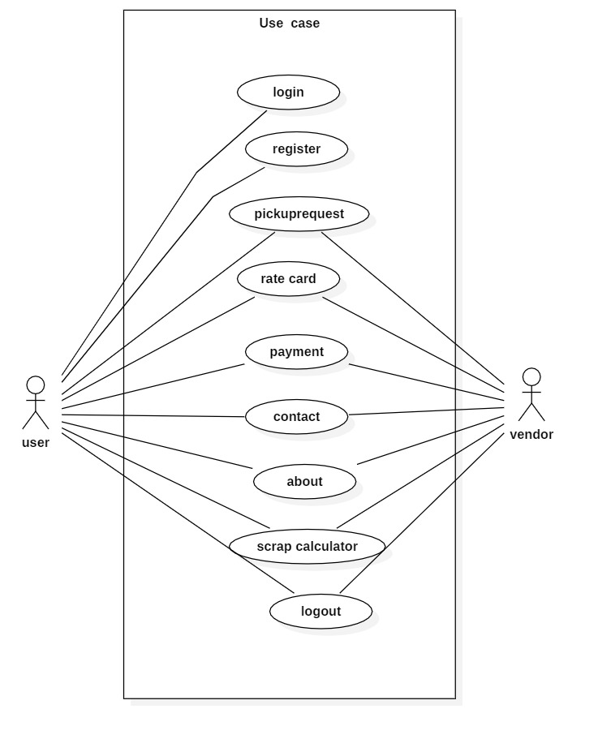

**Staff and Admin –**

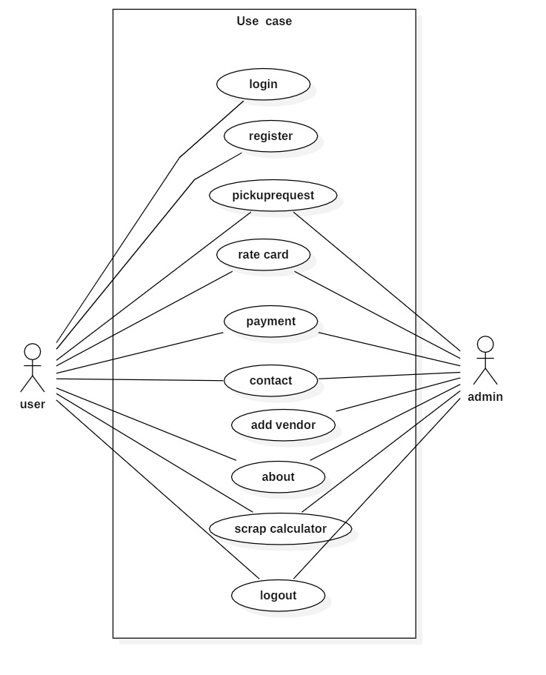

**ClassDiagram–**

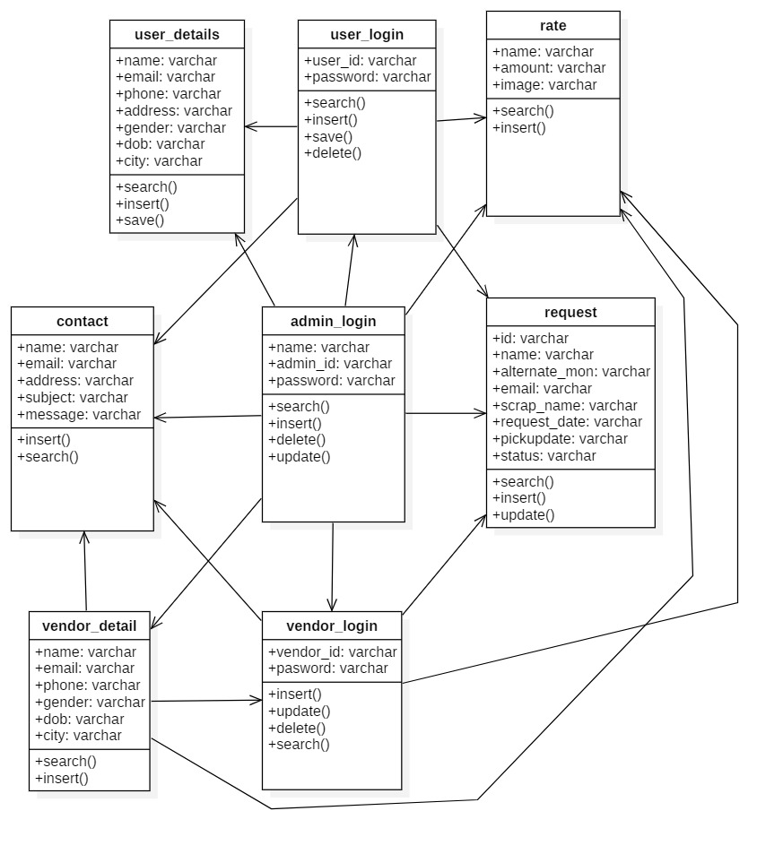

**Entity Relationship Diagramwith Data Flow –**

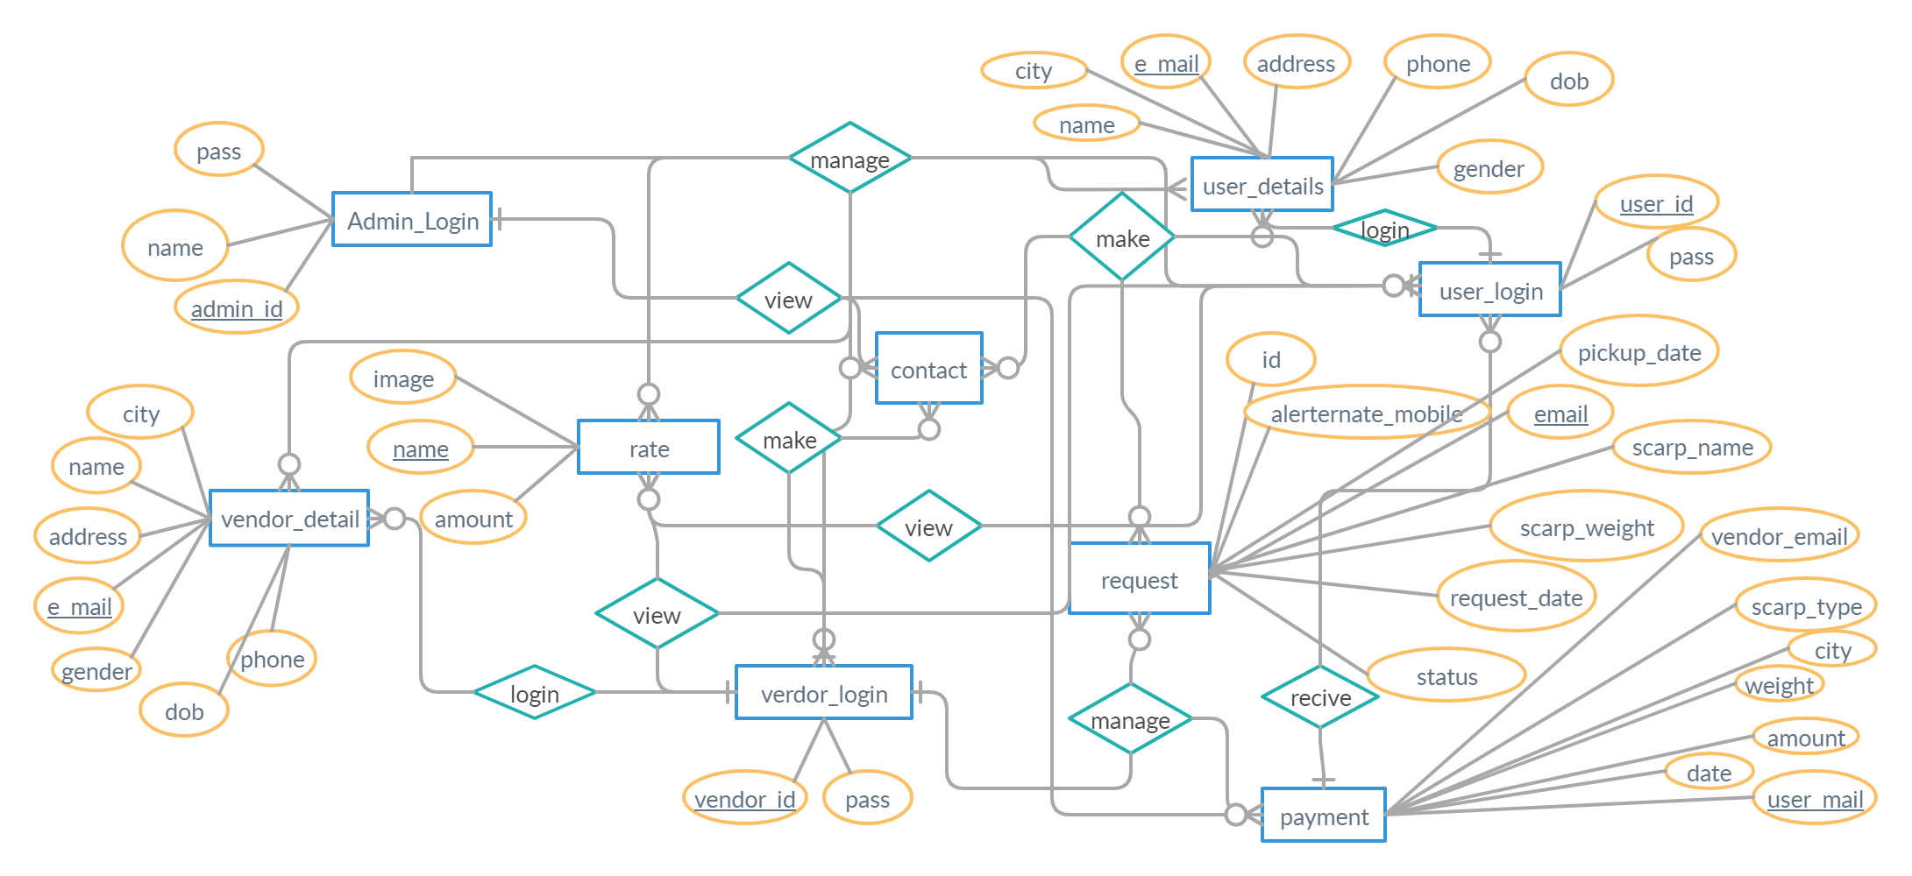

**Component Diagram:-**

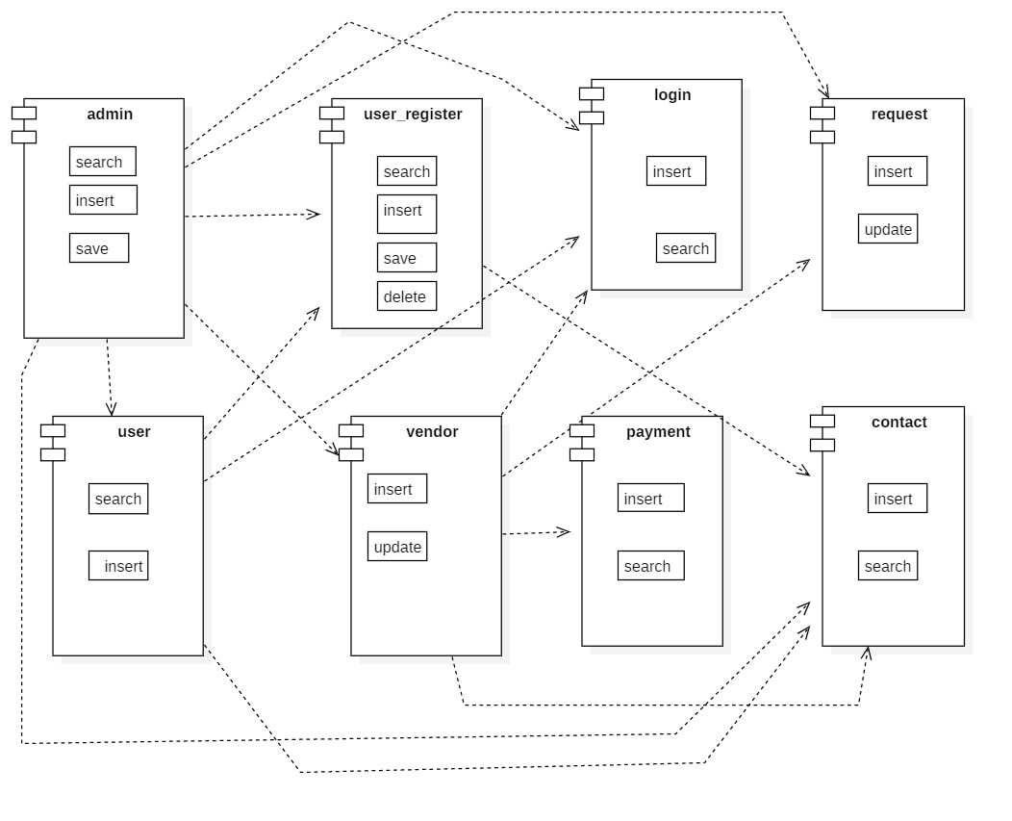

**GANTT CHART –**

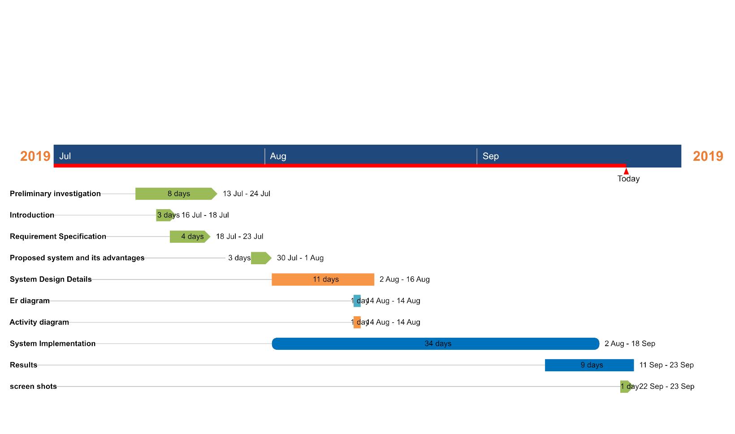

**Test Case: Admin Login Page**

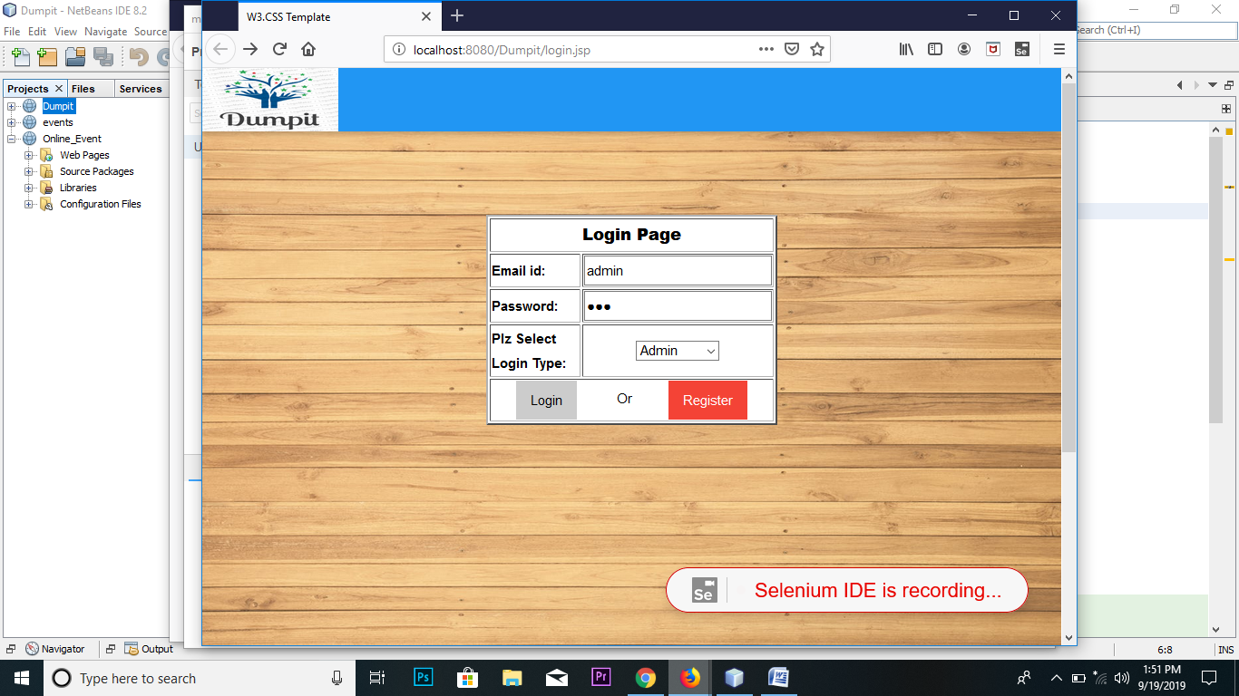

**Test Case: Admin Remove User**

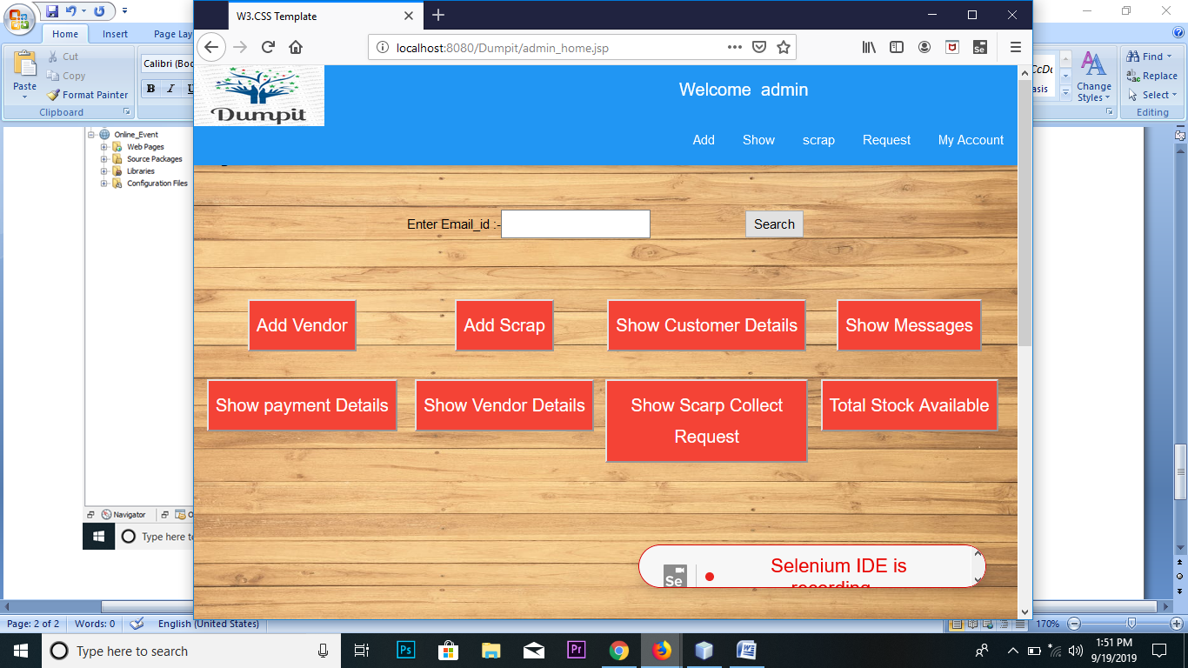

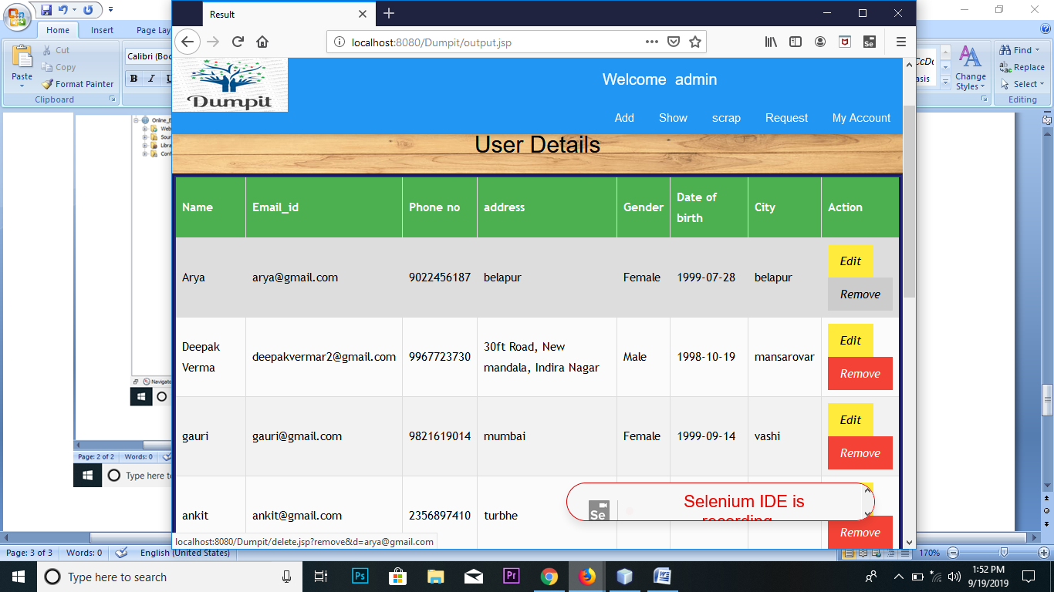

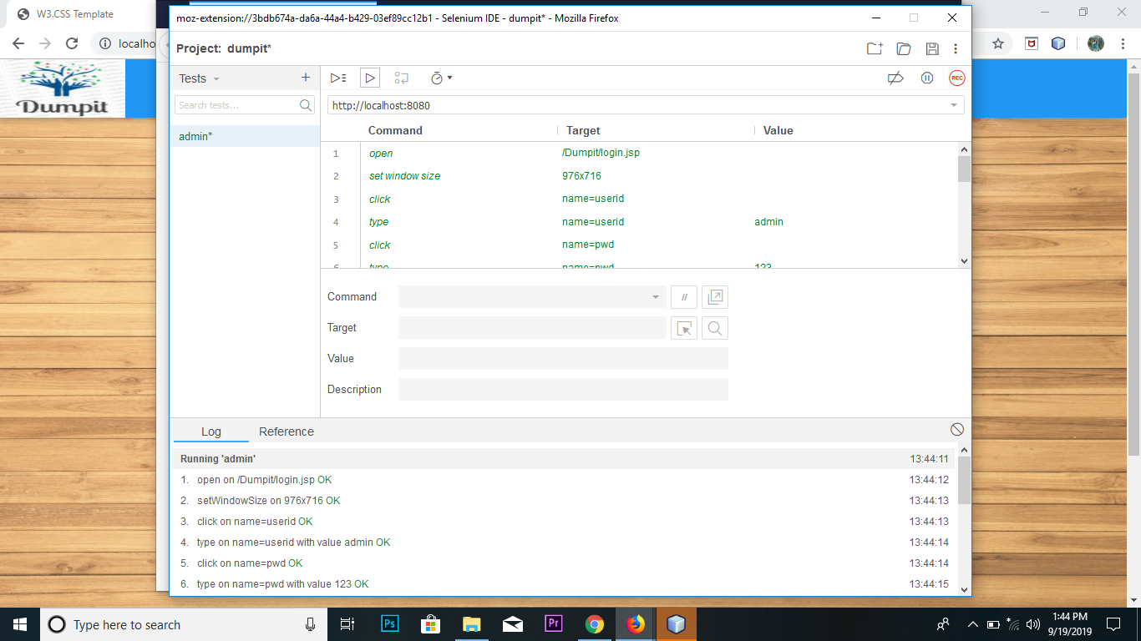

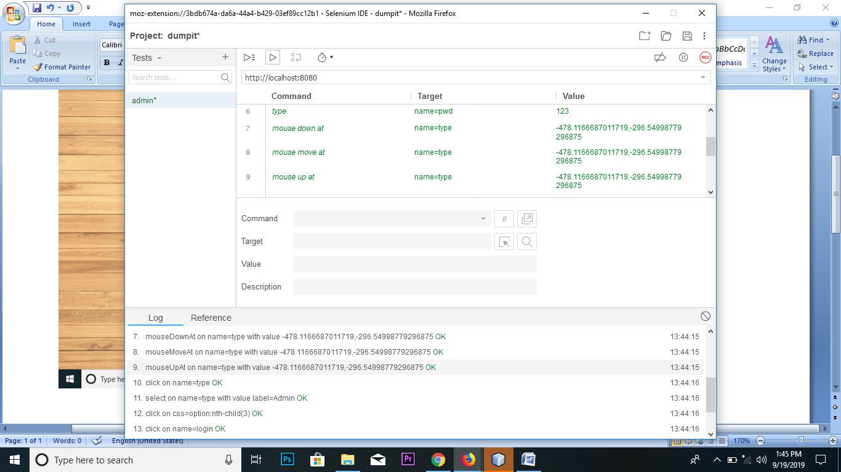

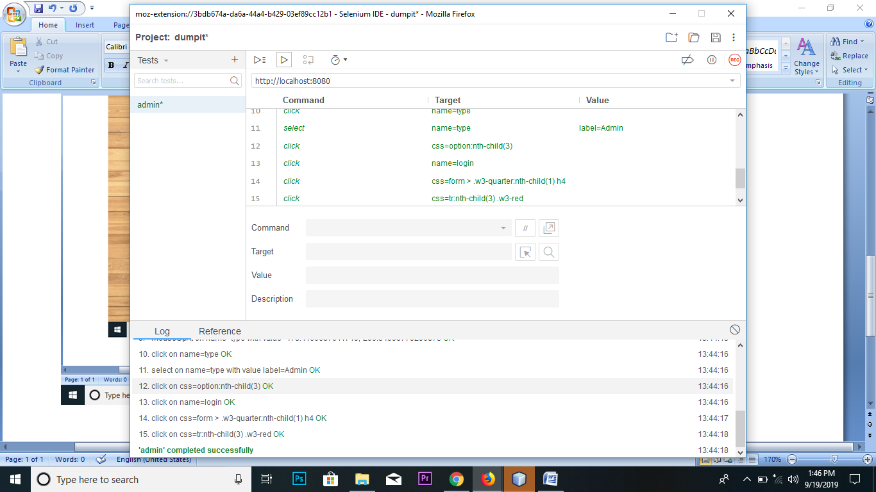

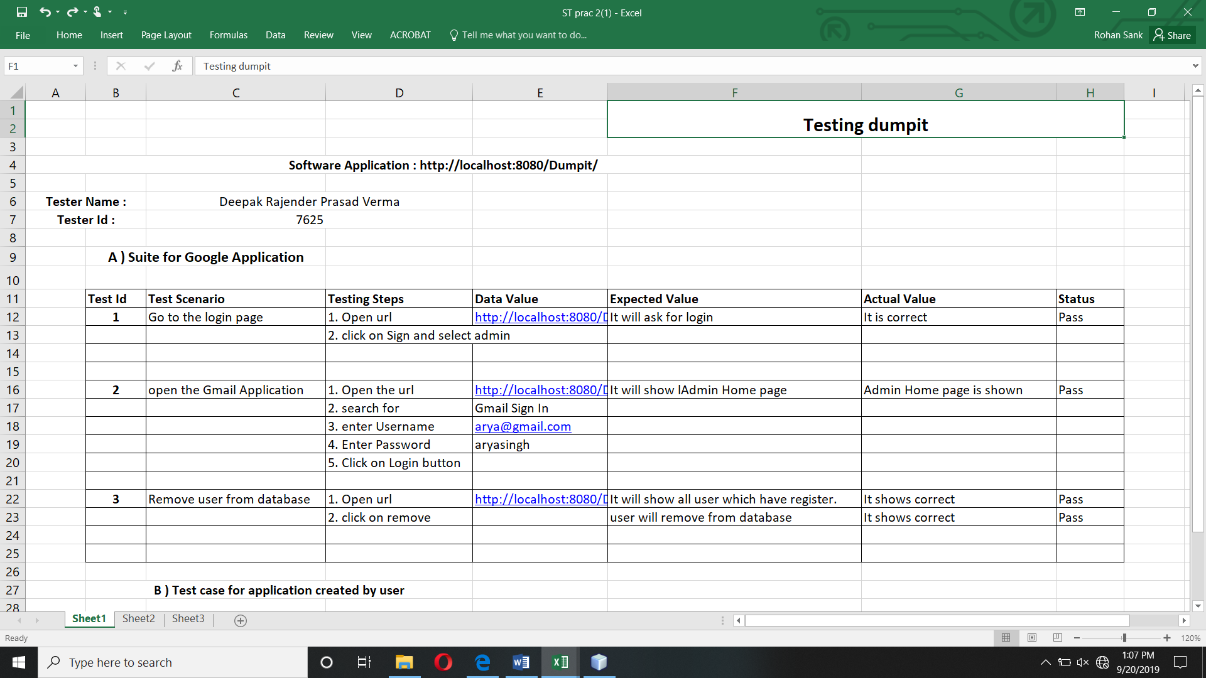

1. **SYSTEM DESIGN**

**Home.jsp**

**Code:-**

<!DOCTYPE jsp>

<title>Home </title>

<meta charset="UTF-8">

<meta name="viewport" content="width=device-width, initial-scale=1">

<link rel="stylesheet" href="project.css">

<link rel="stylesheet" href="https://fonts.googleapis.com/css?family=Raleway">

<link rel="stylesheet" href="https://cdnjs.cloudflare.com/ajax/libs/font-awesome/4.7.0/css/font-awesome.min.css">

<style>

body,h1,h2,h3,h4,h5,h6 {font-family: "Raleway", sans-serif}

body, jsp {

height: 100%;

line-height: 1.8;

background-image:url("./images/background.jpeg");

background-attachment:fixed;

background-size: 100% 100%;

}

.w3-bar .w3-button {

padding: 16px;

}

</style>

<body >

<!-- Navbar (sit on top) -->

<%

boolean flag= false;

if(session.getAttribute("vendor")!=null)

{ flag=true;

%>

<jsp:include page="vendor_header.jsp"/>

<%}%>

<%

if(session.getAttribute("user")!=null)

{flag=true;

%>

<jsp:include page="user_header.jsp"/>

<%}%>

<%

if(session.getAttribute("admin")!=null)

{flag=true;

%>

<jsp:include page="admin_header.jsp"/>

<%}%>

<% if(flag==false)

{%>

<jsp:include page="home_header.jsp"/>

<%}%>

<!-- servives --><br><br><br><br>

<Center><h2><b>Services</b></h2>

<img src="./images/scrap_collector.jpg" height="420" width="600" ><br><a href="request.jsp" ><b>Scrap pickup</b></a>

<p> Raise a pickup now! Our vendor will come to you on the scheduled time to pick up your scrap in exchange for money.</p>

<img src=".\images\ratecard_calculator.png" ><br><a href="rate_calculator.jsp" ><b>Scrap rate calculator</b></a>

<p> Want to know the worth of your scrap before selling it of? Use our calculator to calculate how much your waste is worthy.</p>

<img src=".\images\corporate.png" ><br><a href="#" ><b>Corporate Tie-up</b></a>

<p> We have customized panel for corporates to systematically get rid of the scrap and get certificates of recycling.</p>

</center>

<!-- rate card-->

<Center><a href="rate.jsp" ><h2>

<b>Rate Card</b></h2></a></center>

<div class="w3-row-padding w3-margin-bottom">

<div class="w3-quarter">

<div class="w3-container w3-red w3-padding-16">

<div class="w3-left"><img src=".\images\rate\iron.png" ></div>

<div class="w3-center">

<strong><span class="text-success">Rs</span> 10.00 <small>per Kg</small></strong>

</div>

<h3>Iron</h3>

</div>

</div>

<div class="w3-quarter">

<div class="w3-container w3-blue w3-padding-16">

<div class="w3-left"><img src=".\images\rate\brass.png" ></div>

<div class="w3-center">

<strong><span class="text-success">Rs</span> 240.00 <small>per Kg</small></strong>

</div>

<h4>Brass</h4>

</div>

</div>

<div class="w3-quarter">

<div class="w3-container w3-teal w3-padding-16">

<div class="w3-left"><img src=".\images\rate\copper.png" ></div>

<div class="w3-center">

<strong><span class="text-success">Rs</span> 350.00 <small>per Kg</small></strong>

</div>

<h4>Copper</h4>

</div>

</div>

<div class="w3-quarter">

<div class="w3-container w3-orange w3-text-white w3-padding-16">

<div class="w3-left"><img src=".\images\rate\newspaper.png" ></i></div>

<div class="w3-center">

<strong><span class="text-success">Rs</span> 10.00 <small>per Kg</small></strong>

</div>

<h4>Newspaper</h4>

</div>

</div>

</div>

<!-- Footer -->

<jsp:include page="footer.jsp" />

<script>

// Modal Image Gallery

function onClick(element) {

document.getElementById("img01").src = element.src;

document.getElementById("modal01").style.display = "block";

var captionText = document.getElementById("caption");

captionText.innerjsp = element.alt;

}

// Toggle between showing and hiding the sidebar when clicking the menu icon

var mySidebar = document.getElementById("mySidebar");

function w3_open() {

if (mySidebar.style.display === 'block') {

mySidebar.style.display = 'none';

} else {

mySidebar.style.display = 'block';

}

}

// Close the sidebar with the close button

function w3_close() {

mySidebar.style.display = "none";

}

</script>

</body>

**Output:-**

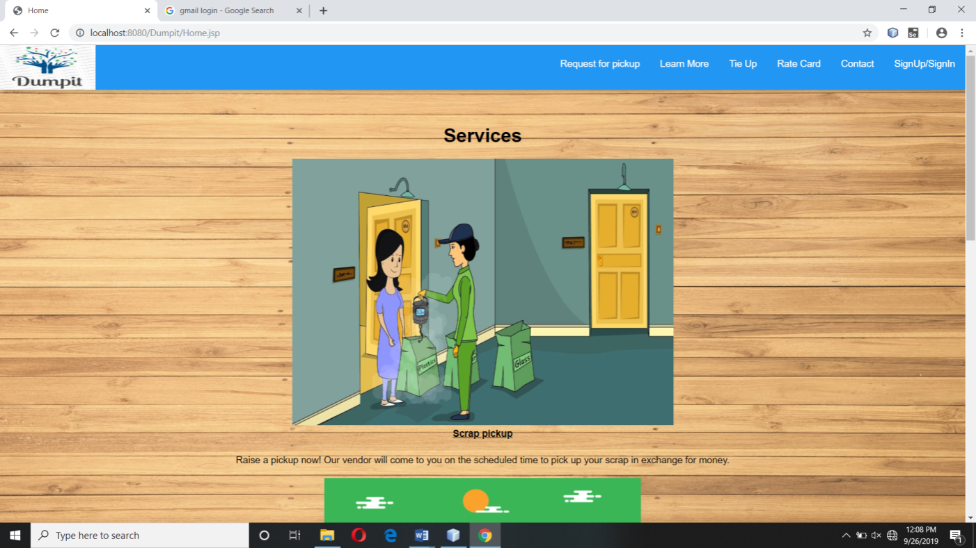

**registration.jsp**

<%@page import="java.security.MessageDigest"%>

<%@page import="java.util.Date"%>

<%@page import="java.sql.ResultSet"%>

<%@page import="java.sql.PreparedStatement"%>

<%@page import="java.sql.DriverManager"%>

<%@page import="java.sql.Connection"%>

<!DOCTYPE html>

<html>

<title>Registration</title>

<meta charset="UTF-8">

<meta name="viewport" content="width=device-width, initial-scale=1">

<link rel="stylesheet" href="project.css">

<link rel="stylesheet" href="https://fonts.googleapis.com/css?family=Raleway">

<link rel="stylesheet" href="https://cdnjs.cloudflare.com/ajax/libs/font-awesome/4.7.0/css/font-awesome.min.css">

<style>

body,h1,h2,h3,h4,h5,h6 {font-family: "Raleway", sans-serif}

body, html {

height: 100%;

line-height: 1.8;

background-image: url("./images/background.jpeg");

background-size: 100% 100%;

}

#customers {

font-family: "Trebuchet MS", Arial, Helvetica, sans-serif;

border-collapse: collapse;

}

#customers td, #customers th {

border: 1px solid #ddd;

padding: 8px;

}

#customers tr:nth-child(even){background-color: #f2f2f2;}

#customers tr:hover {background-color: #ddd;}

#customers th {

padding-top: 12px;

padding-bottom: 12px;

text-align: left;

}

</style>

<script>

// Function to check Whether both passwords

// is same or not.

function checkPassword() {

= password1.value;

= password2.value;

var = document.getElementById("password1");

var = document.getElementById("password2");

// If password not entered

if (password1 === '')

alert ('Please enter Password');

// If confirm password not entered

else if (password2 === '')

alert ('Please enter confirm password');

// If Not same return False.

else if (password1 !== password2) {

alert ('\nPassword did not match: Please try again...') ;

return false;

}

// If same return True.

else{

return true;

}

}

</script>

<body>

<jsp:include page="home_header.jsp"/>

<!-- Navbar (sit on top) -->

<div class="w3-top">

<div class="w3-bar w3-blue w3-card" id="myNavbar">

<a href="Home.jsp" ><img src=".\images\logo.png" height="70" width="150" ></a>

<!-- Right-sided navbar links -->

<!-- Hide right-floated links on small screens and replace them with a menu icon -->

<a href="javascript:void(0)" class="w3-bar-item w3-button w3-right w3-hide-large w3-hide-medium" onclick="w3_open()">

<i class="fa fa-bars"></i>

</a>

</div>

</div>

<!-- Sidebar on small screens when clicking the menu icon -->

<!--Registration-->

<br><br><br><br>

<form action="registration.jsp" method="post" onsubmit="checkPassword()">

<table border="5" id="customers" bordercolor="#272785" method="post"align="center" width="41%" bgcolor="#FBFBFB" >

<caption><strong><h2>Registration</strong></h2></caption>

<tr>

<th>Enter your name</th>

<td><center><input type="text" name="name" id="name" maxlength="20" placeholder=" Enter your name" required/></td>

</center>

</tr>

<tr>

<th>Enter your password</th>

<td><center><input type="password" name="password1" pattern=".{6,}" title="Six or more characters" placeholder=" Enter password" required/></td>

</center>

</tr>

<tr>

<th>ReEnter your password</th>

<td><center><input type="password" name="password2"placeholder=" Plz Re-enter your password" required/></td>

</center>

</tr>

<tr>

<th>Enter your email</th>

<td><center><input name="email"type="email" placeholder=" Enter your email" required/></td>

</center>

</tr>

<tr>

<th>Enter your mobile</th>

<td><center><input type="text" pattern="[0-9]{8-10}" name="mobile" titel="Enter proper mobile no" placeholder="Enter your Mobile no." required/></td>

</center>

</tr>

<tr>

<th>Enter your address</th>

<td><center><textarea rows="4" cols="20" name="address"></textarea></td>

</center>

</tr>

<tr>

<th>Select your City</th>

<td><center>

<select name="city" required>

<option value="" selected="selected" disabled="disabled">Select your City</option>

<option value="vashi">vashi</option>

<option value="govandi">govandi</option>

<option value="mansarovar">mansarovar</option>

<option value="belapur">belapur</option>

<option value="bandra">bandra</option>

<option value="mankhurd">mankhurd</option>

<option value="chembur">chembur</option>

<option value="kurla">kurla</option>

<option value="sanpada">sanpada</option>

<option value="nerul">nerul</option>

<option value="panvel">panvel</option>

</select>

</center>

</td>

</tr>

<tr>

<th>Select your gender</th>

<td><center>

<input type="radio" name="gender" value="Male"/>Male

<input type="radio" name="gender" value="Female"/>Female

</center>

</td>

</tr>

<tr>

<th>Select your DOB</th>

<td><center><input type="date" name="dob" required/></td>

</center>

</tr>

<tr>

<td colspan="2" align="center"><input type="submit" name="register" value="Register"/>

<input type="reset" value="Reset Data"/>

</td>

</tr>

</table>

</form>

<br><br>

<!-- Footer -->

<jsp:include page="footer.jsp" ></jsp:include>

<script>

// Modal Image Gallery

function onClick(element) {

document.getElementById("img01").src = element.src;

document.getElementById("modal01").style.display = "block";

var captionText = document.getElementById("caption");

captionText.innerHTML = element.alt;

}

// Toggle between showing and hiding the sidebar when clicking the menu icon

var mySidebar = document.getElementById("mySidebar");

function w3_open() {

if (mySidebar.style.display === 'block') {

mySidebar.style.display = 'none';

} else {

mySidebar.style.display = 'block';

}

}

// Close the sidebar with the close button

function w3_close() {

mySidebar.style.display = "none";

}

</script>

</body>

</html>

<%--

Document : reg_code

Created on : Aug 25, 2019, 2:02:47 AM

Author : Deepak

--%>

<%

if(request.getParameter("register")!=null){

try{

String name=request.getParameter("name");

String pass=request.getParameter("password1");

String selectedcity=request.getParameter("city");

String email=request.getParameter("email");

String mobile=request.getParameter("mobile");

String address=request.getParameter("address");

String gender=request.getParameter("gender");

String dob=request.getParameter("dob");

//----------MD5 Implementation--------------------------------------------------------

MessageDigest mdAlgorithm = MessageDigest.getInstance("MD5");

mdAlgorithm.update(pass.getBytes());

byte[] digest = mdAlgorithm.digest();

StringBuffer hexString = new StringBuffer();

for (int i = 0; i < digest.length; i++) {

pass = Integer.toHexString(0xFF & digest[i]);

if (pass.length() < 2) {

pass = "0" + pass;

}

hexString.append(pass);

}

String password =hexString.toString();

Class.forName("com.mysql.jdbc.Driver");

Connection con= DriverManager.getConnection("jdbc:mysql://localhost:3306/dumpit","root","");

PreparedStatement ps=con.prepareStatement("insert into user_detail values(?,?,?,?,?,?,?)");

ps.setString(1, name);

ps.setString(2, email);

ps.setString(3,mobile);

ps.setString(4, address);

ps.setString(5, gender);

ps.setString(6,dob);

ps.setString(7, selectedcity);

int i=ps.executeUpdate();

if(i>0)

{

PreparedStatement login=con.prepareStatement("insert into user_login values(?,?)");

login.setString(1, email);

login.setString(2,password);

login.executeUpdate();

out.print("<script>alert('Register Successfully Please go and Login');</script>");

response.sendRedirect("login.jsp");

}

else

{

out.print("<script>alert('Some Thing wnt wrong try again');</script>");

}

}catch(Exception ex){

out.print(ex);

out.print("<script>alert('"+ex+"');</script>");

}

}

%>

**Output:-**

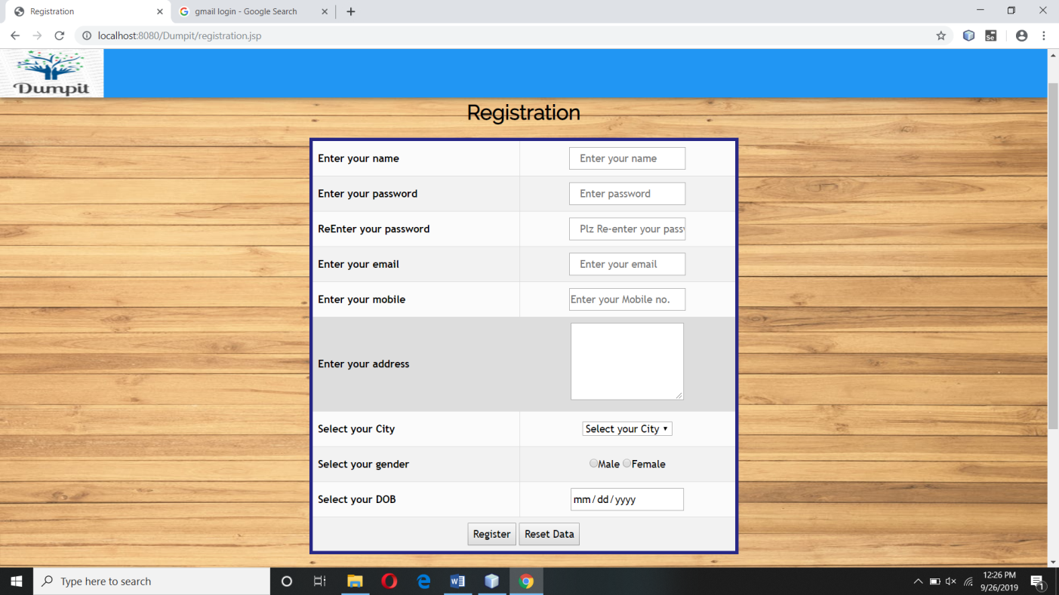

**login.jsp**

**Code:-**

<%@page import="java.security.MessageDigest"%>

<%@page import="java.sql.ResultSet"%>

<%@page import="java.util.Date"%>

<%@page import="java.sql.PreparedStatement"%>

<%@page import="java.sql.DriverManager"%>

<%@page import="java.sql.Connection"%>

<%@page contentType="text/html" pageEncoding="UTF-8"%>

<!DOCTYPE html>

<html>

<title>Login</title>

<meta charset="UTF-8">

<meta name="viewport" content="width=device-width, initial-scale=1">

<link rel="stylesheet" href="project.css">

<link rel="stylesheet" href="https://fonts.googleapis.com/css?family=Raleway">

<link rel="stylesheet" href="https://cdnjs.cloudflare.com/ajax/libs/font-awesome/4.7.0/css/font-awesome.min.css">

<style>

body,h1,h2,h3,h4,h5,h6 {font-family: "Raleway", sans-serif}

body, html {

height: 100%;

line-height: 1.8;

background-size: 100% 100%;

background-image: url("./images/background.jpeg");

}

.w3-bar .w3-button {

padding: 16px;

}

</style>

<body >

<!-- Navbar (sit on top) -->

<div class="w3-top">

<div class="w3-bar w3-blue w3-card" id="myNavbar">

<a href="Home.jsp" ><img src=".\images\logo.png" height="70" width="150" ></a>

<!-- Right-sided navbar links -->

<!-- Hide right-floated links on small screens and replace them with a menu icon -->

<a href="javascript:void(0)" class="w3-bar-item w3-button w3-right w3-hide-large w3-hide-medium" onclick="w3_open()">

<i class="fa fa-bars"></i>

</a>

</div>

</div>

<!-- Sidebar on small screens when clicking the menu icon

<nav class="w3-sidebar w3-bar-block w3-black w3-card w3-animate-left w3-hide-medium w3-hide-large" style="display:none" id="mySidebar">

<a href="javascript:void(0)" onclick="w3_close()" class="w3-bar-item w3-button w3-large w3-padding-16">Close ÃƒÂ—</a>

<a href="about.html" onclick="w3_close()" class="w3-bar-item w3-button">About</a>

<a href="request.html" onclick="w3_close()" class="w3-bar-item w3-button">Request for pickup</a>

<a href="#work" onclick="w3_close()" class="w3-bar-item w3-button">WORK</a>

<a href="rate.html" onclick="w3_close()" class="w3-bar-item w3-button">Srcap rate</a>

<a href="rate_calculator.html" onclick="w3_close()" class="w3-bar-item w3-button">Srcap rate Calculator</a>

<a href="contact.html" onclick="w3_close()" class="w3-bar-item w3-button">Contact</a>

<a href="login.html" onclick="w3_close()" class="w3-bar-item w3-button">Log In</a>

<a href="Registration.html" onclick="w3_close()" class="w3-bar-item w3-button">SignUp</a>

</nav>

-->

<!--Login-->

<br><br><br><br><br><br>

<div class="w3-container">

<form action="login.jsp" method="post" >

<table width="35%" height="50%" bgcolor="white" border="2" align="center">

<tr>

<th colspan=2><center><font size=4><b> Login Page</b></font></center></th>

</tr>

<tr>

<td><b>Email id:</b></td>

<td><input type="text" size=25 name="userid"/></td>

</tr>

<tr>

<td><b>Password:</b></td>

<td><input type="Password" size=25 name="pwd"/></td>

</tr>

<tr>

<td><b>Plz Select Login Type:</b></td>

<td><center>

<select name="type" required>

<option value="user" >Customer</option>

<option value="vendor">Vendor</option>

<option value="admin">Admin</option>

</select>

</center>

</td>

</tr>

<tr>

<td colspan="2"><center>

<input class="w3-button w3-green" type="submit" name="login" value="Login"/>

&nbsp;&nbsp;&nbsp;&nbsp;&nbsp;&nbsp;&nbsp;&nbsp;&nbsp; Or&nbsp;&nbsp;&nbsp;&nbsp;&nbsp;&nbsp;&nbsp;&nbsp;&nbsp;

<a href="registration.jsp" <i class="w3-button w3-red">Register</i></a>

</center></td></tr>

</table>

</form>

</div>

<br><br><br><br><br><br><br><br><br><br><br>

<!-- Footer -->

<jsp:include page="footer.jsp" ></jsp:include>

<script>

// Modal Image Gallery

function onClick(element) {

document.getElementById("img01").src = element.src;

document.getElementById("modal01").style.display = "block";

var captionText = document.getElementById("caption");

captionText.innerHTML = element.alt;

}

// Toggle between showing and hiding the sidebar when clicking the menu icon

var mySidebar = document.getElementById("mySidebar");

function w3_open() {

if (mySidebar.style.display === 'block') {

mySidebar.style.display = 'none';

} else {

mySidebar.style.display = 'block';

}

}

// Close the sidebar with the close button

function w3_close() {

mySidebar.style.display = "none";

}

</script>

</body>

</html>

<!DOCTYPE html>

<%

String login_type= request.getParameter("type");

String Email_id =request.getParameter("userid");

String pass=request.getParameter("pwd");

if(request.getParameter("login")!= null){

try{

Class.forName("com.mysql.jdbc.Driver");

Connection con= DriverManager.getConnection("jdbc:mysql://localhost:3306/dumpit","root","");

if(login_type.equals("user")){

//----------MD5 Implementation--------------------------------------------------------

MessageDigest mdAlgorithm = MessageDigest.getInstance("MD5");

mdAlgorithm.update(pass.getBytes());

byte[] digest = mdAlgorithm.digest();

StringBuffer hexString = new StringBuffer();

for (int i = 0; i < digest.length; i++) {

pass = Integer.toHexString(0xFF & digest[i]);

if (pass.length() < 2) {

pass = "0" + pass;

}

hexString.append(pass);

}

String password=hexString.toString();

//-------------------------------------------------------------------------------

PreparedStatement ps=con.prepareStatement("select *from user_login where user_id like '"+Email_id+"' and pass like '"+password+"'");

ResultSet rs=ps.executeQuery();

if(rs.next()){

PreparedStatement ps_name=con.prepareStatement("select name from user_detail where e_mail like '"+Email_id+"'");

ResultSet rs_name=ps_name.executeQuery();

if(rs_name.next()){

String name= rs_name.getString("name") ;

session.setAttribute("name",name);

}

session.setAttribute("user",Email_id);

response.sendRedirect("user_home.jsp");

out.print("<script>alert('success');</script>");

}

else{

out.print("<script>alert('Invailid Email_id or password');</script>");

}

}

////-------------------- For Vendor------------------

if(login_type.equals("vendor")){

//----------MD5 Implementation--------------------------------------------------------

MessageDigest mdAlgorithm = MessageDigest.getInstance("MD5");

mdAlgorithm.update(pass.getBytes());

byte[] digest = mdAlgorithm.digest();

StringBuffer hexString = new StringBuffer();

for (int i = 0; i < digest.length; i++) {

pass = Integer.toHexString(0xFF & digest[i]);

if (pass.length() < 2) {

pass = "0" + pass;

}

hexString.append(pass);

}

String password=hexString.toString();

//-------------------------------------------------------------------------------

PreparedStatement ps=con.prepareStatement("select *from vendor_login where vendor_id like '"+Email_id+"' and pass like '"+password+"'");

ResultSet rs=ps.executeQuery();

if(rs.next()){

PreparedStatement ps_name=con.prepareStatement("select name from vendor_detail where e_mail like '"+Email_id+"'");

ResultSet rs_name=ps_name.executeQuery();

if(rs_name.next()){

String name= rs_name.getString("name") ;

session.setAttribute("name",name);

}

response.sendRedirect("vendor_home.jsp");

session.setAttribute("vendor",Email_id);

}

else{

out.print("<script>alert('Invailid Email_id or password');</script>");

}

}

// for Admin

if(login_type.equals("admin")){

PreparedStatement ps=con.prepareStatement("select *from admin_login where admin_id like '"+Email_id+"' and pass like '"+pass+"'");

ResultSet rs=ps.executeQuery();

if(rs.next()){

PreparedStatement ps_name=con.prepareStatement("select name from admin_login where admin_id like '"+Email_id+"'");

ResultSet rs_name=ps_name.executeQuery();

if(rs_name.next()){

String name= rs_name.getString("name") ;

session.setAttribute("name",name);

}

session.setAttribute("admin",Email_id);

response.sendRedirect("admin_home.jsp");

}

else{

out.print("<script>alert('Invailid Email_id or password');</script>");

}

}

}

catch(Exception ex){

out.println("<script>alert('"+ex+"');</script>");

}

}

%>

**Output:-**

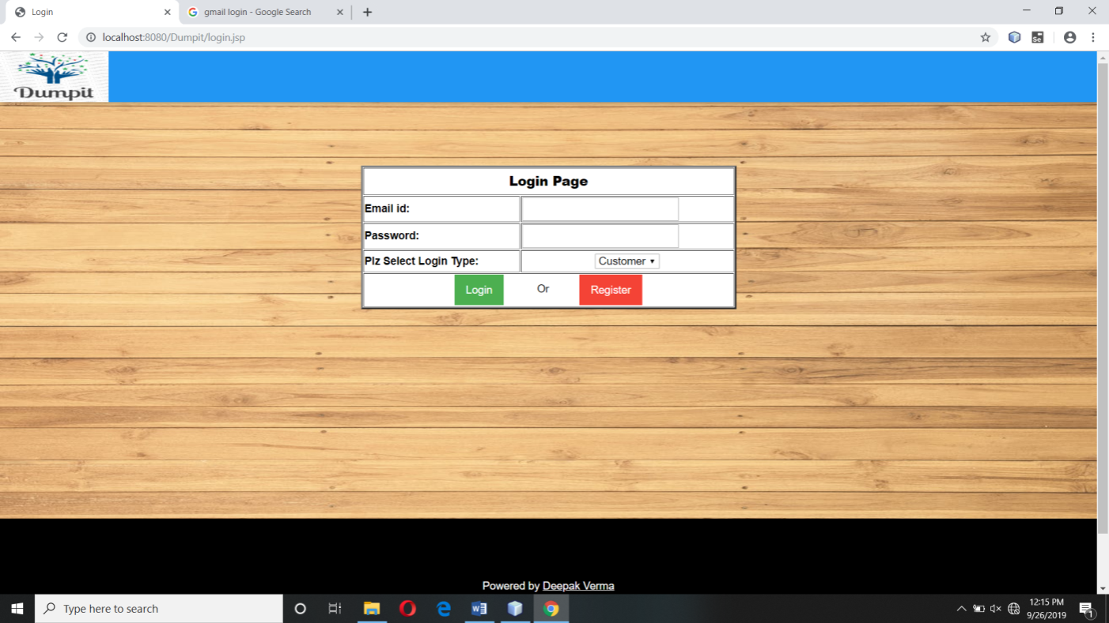

**user_home.jsp**

**Code:-**

<!DOCTYPE html>

<html>

<title>User Home</title>

<meta charset="UTF-8">

<meta name="viewport" content="width=device-width, initial-scale=1">

<link rel="stylesheet" href="project.css">

<link rel="stylesheet" href="https://fonts.googleapis.com/css?family=Raleway">

<link rel="stylesheet" href="https://cdnjs.cloudflare.com/ajax/libs/font-awesome/4.7.0/css/font-awesome.min.css">

<style>

body,h1,h2,h3,h4,h5,h6 {font-family: "Raleway", sans-serif}

body, jsp {

height: 100%;

line-height: 1.8;

background-image:url("./images/background.jpeg");

background-attachment:fixed;

background-size: 100% 100%;

}

.w3-bar .w3-button {

padding: 16px;

}

</style>

<body >

<jsp:include page="user_header.jsp"/>

<%if(session.getAttribute("user")==null){

response.sendRedirect("login.jsp");

}%>

<!-- Navbar (sit on top) -->

<!-- servives --><br><br>

<Center><h2><b>Services</b></h2>

<img src=".\images\pickup.png" ><br><a href="request.jsp" ><b>Scrap pickup</b></a>

<p> Raise a pickup now! Our vendor will come to you on the scheduled time to pick up your scrap in exchange for money.</p>

<img src=".\images\ratecard_calculator.png" ><br><a href="rate_calculator.jsp" ><b>Scrap rate calculator</b></a>

<p> Want to know the worth of your scrap before selling it of? Use our calculator to calculate how much your waste is worthy.</p>

<img src=".\images\corporate.png" ><br><a href="#" ><b>Corporate Tie-up</b></a>

<p> We have customized panel for corporates to systematically get rid of the scrap and get certificates of recycling.</p>

</center>

<!-- rate acrd-->

<Center><a href="rate.jsp" ><h2>

<b>Rate Card</b></h2></a></center>

<div class="w3-row-padding w3-margin-bottom">

<div class="w3-quarter">

<div class="w3-container w3-red w3-padding-16">

<div class="w3-left"><img src=".\images\rate\iron.png" ></div>

<div class="w3-center">

<strong><span class="text-success">Rs</span> 10.00 <small>per Kg</small></strong>

</div>

<h3>Iron</h3>

</div>

</div>

<div class="w3-quarter">

<div class="w3-container w3-blue w3-padding-16">

<div class="w3-left"><img src=".\images\rate\brass.png" ></div>

<div class="w3-center">

<strong><span class="text-success">Rs</span> 240.00 <small>per Kg</small></strong>

</div>

<h4>Brass</h4>

</div>

</div>

<div class="w3-quarter">

<div class="w3-container w3-teal w3-padding-16">

<div class="w3-left"><img src=".\images\rate\copper.png" ></div>

<div class="w3-center">

<strong><span class="text-success">Rs</span> 350.00 <small>per Kg</small></strong>

</div>

<h4>Copper</h4>

</div>

</div>

<div class="w3-quarter">

<div class="w3-container w3-orange w3-text-white w3-padding-16">

<div class="w3-left"><img src=".\images\rate\newspaper.png" ></i></div>

<div class="w3-center">

<strong><span class="text-success">Rs</span> 10.00 <small>per Kg</small></strong>

</div>

<h4>Newspaper</h4>

</div>

</div>

</div>

<!-- Footer -->

<jsp:include page="footer.jsp" ></jsp:include>

<script>

// Modal Image Gallery

function onClick(element) {

document.getElementById("img01").src = element.src;

document.getElementById("modal01").style.display = "block";

var captionText = document.getElementById("caption");

captionText.innerHTML = element.alt;

}

// Toggle between showing and hiding the sidebar when clicking the menu icon

var mySidebar = document.getElementById("mySidebar");

function w3_open() {

if (mySidebar.style.display === 'block') {

mySidebar.style.display = 'none';

} else {

mySidebar.style.display = 'block';

}

}

// Close the sidebar with the close button

function w3_close() {

mySidebar.style.display = "none";

}

</script>

</body>

</html>

**Output:-**

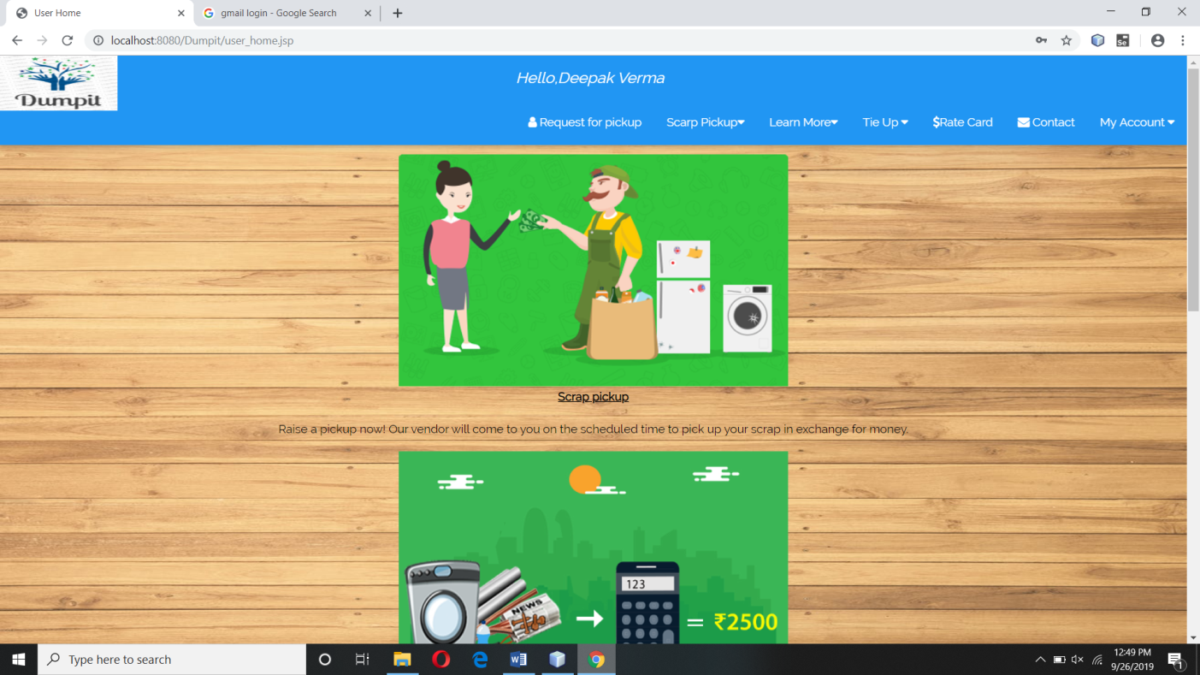

**request.jsp**

**Code:-**

<%@page import="java.security.MessageDigest"%>

<%@page import="java.util.Date"%>

<%@page import="java.sql.ResultSet"%>

<%@page import="java.sql.PreparedStatement"%>

<%@page import="java.sql.DriverManager"%>

<%@page import="java.sql.Connection"%>

<!DOCTYPE html>

<html>

<title>Pick Up Request</title>

<meta charset="UTF-8">

<meta name="viewport" content="width=device-width, initial-scale=1">

<link rel="stylesheet" href="project.css">

<link rel="stylesheet" href="https://fonts.googleapis.com/css?family=Raleway">

<link rel="stylesheet" href="https://cdnjs.cloudflare.com/ajax/libs/font-awesome/4.7.0/css/font-awesome.min.css">

<style>

body,h1,h2,h3,h4,h5,h6 {font-family: "Raleway", sans-serif}

body, html {

height: 100%;

line-height: 1.8;

background-image: url("./images/background.jpeg");

background-size: 100% 100%;

}

#customers {

font-family: "Trebuchet MS", Arial, Helvetica, sans-serif;

border-collapse: collapse;

}

#customers td, #customers th {

border: 1px solid #ddd;

padding: 8px;

}

#customers tr:nth-child(even){background-color: #f2f2f2;}

#customers tr:hover {background-color: #ddd;}

#customers th {

padding-top: 12px;

padding-bottom: 12px;

text-align: left;

}

</style>

<body>

<!-- Navbar (sit on top) -->

<%

boolean flag= false;

if(session.getAttribute("vendor")!=null)

{ flag=true;

%>

<jsp:include page="vendor_header.jsp"/>

<%}%>

<%

if(session.getAttribute("user")!=null)

{flag=true;

%>

<jsp:include page="user_header.jsp"/>

<%}else{response.sendRedirect("login.jsp");}%>

<%

if(session.getAttribute("admin")!=null)

{flag=true;

%>

<jsp:include page="admin_header.jsp"/>

<%}%>

<% if(flag==false)

{%>

<jsp:include page="home_header.jsp"/>

<%}%><!--Registration-->

<br><br><br><br>

<form action="request.jsp" method="post" >

<table border="5" bordercolor="#272785" id="customers" align="center" width="41%" bgcolor="#FBFBFB" >

<caption><strong><h2>Request for Pickup now</strong></h2></caption>

<tr>

<th>Enter Scarp Type</th>

<td><center>

<select name="item" required>

<option value="" >Select scarp type</option>

<%

try{

Class.forName("com.mysql.jdbc.Driver");

Connection con= DriverManager.getConnection("jdbc:mysql://localhost:3306/dumpit","root","");

PreparedStatement ps=con.prepareStatement("select * from rate");

ResultSet rs=ps.executeQuery();

while(rs.next()){

%>

<option value="<%=rs.getString("name") %>"><%=rs.getString("name") %></option>

<%}

}catch(Exception ex){

out.print("<script>alert('"+ex+"')</script>");

}

%>

</select>

</center>

</td>

</tr>

<tr>

<th>Alternate Mobile No</th>

<td><center><input type="text" pattern="[0-9]{8-10}" maxlength="10" name="altmobile" placeholder="Enter your alt mobile no" required/>

</td></center>

</tr>

<tr>

<th>Enter Scrap Weight </th>

<td><center>

<input type="text" name="weight" placeholder="Enter Weight in KG" />

</td>

</center>

</tr>

<tr>

<th>Pick up Date and date</th>

<td><center><input type="date" name="date" min="<%=(new java.util.Date()).toString()%>" placeholder=" Select your date of birth" required/>&nbsp;

</td>

</center>

</tr>

<tr>

<td colspan="2" align="center">

<input class="w3-red" type="reset" value="Reset Data"/>

&nbsp; &nbsp; &nbsp; &nbsp; &nbsp; &nbsp; &nbsp; &nbsp; &nbsp; &nbsp; &nbsp; &nbsp; &nbsp; &nbsp; &nbsp; &nbsp; &nbsp; &nbsp;

<input class="w3-red" type="submit" name="send" value="Send Request"/>

</td>

</tr>

</table>

</form>

<br><br>

<!-- Footer -->

<footer class="w3-center w3-black w3-padding-64">

<p>Powered by Deepak verma</p>

</footer>

</body>

</html>

<%

if(request.getParameter("send")!=null){

try{

String name,city,mobile,address;

String altmobile =request.getParameter("altmobile");

int scarp_weigth =Integer.parseInt(request.getParameter("weight"));

String scarp_name =request.getParameter("item");

String pickup_date =request.getParameter("date");

String email = session.getAttribute("user").toString();

Class.forName("com.mysql.jdbc.Driver");

Connection con= DriverManager.getConnection("jdbc:mysql://localhost:3306/dumpit","root","");

PreparedStatement ps=con.prepareStatement("select * from user_detail where e_mail like '"+email+"'");

ResultSet rs=ps.executeQuery();

if(rs.next())

{

name =rs.getString("name");

mobile =rs.getString("phone");

address =rs.getString("address");

city =rs.getString("city");

PreparedStatement p=con.prepareStatement("insert into request(name,mobile,alternate_moblie,email,address,city,scarp_name,scarp_weight,request_date,pickup_date) values(?,?,?,?,?,?,?,?,?,?)");

p.setString(1, name);

p.setString(2, mobile);

p.setString(3, altmobile);

p.setString(4, email);

p.setString(5, address);

p.setString(6, city );

p.setString(7, scarp_name);

p.setInt(8, scarp_weigth);

p.setString(9, ""+new java.util.Date()+"");

p.setString(10, pickup_date);

p.executeUpdate();

out.print("<script>alert('Request Send Successfully');</script>");

}

else

{

out.print("<script>alert('Some Thing wnt wrong try again');</script>");

}

}catch(Exception ex){

out.print(ex);

out.print("<script>alert('"+ex+"');</script>");

}

}

%>

**Output:-**

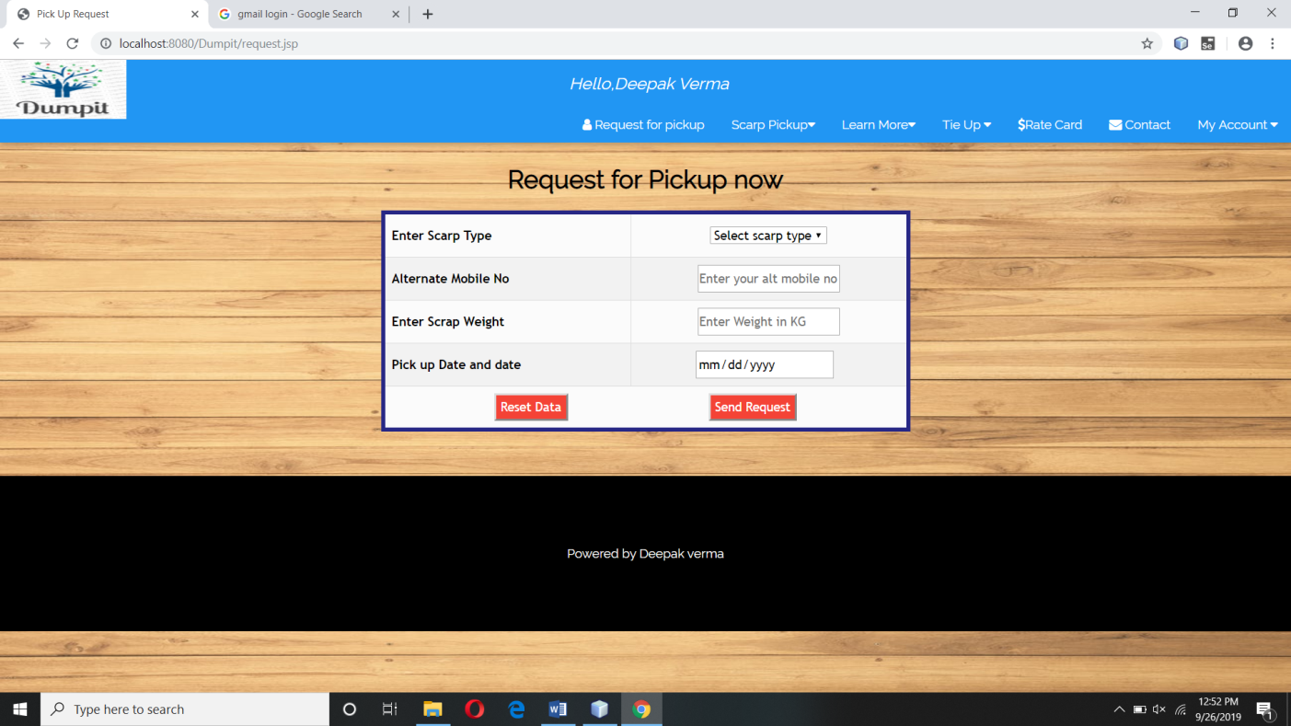

**rate_calculator.jsp**

<%@page import="java.sql.ResultSet"%>

<%@page import="java.sql.PreparedStatement"%>

<%@page import="java.sql.DriverManager"%>

<%@page import="java.sql.Connection"%>

<!DOCTYPE html>

<html>

<title>Rate Calculator</title>

<meta charset="UTF-8">

<meta name="viewport" content="width=device-width, initial-scale=1">

<link rel="stylesheet" href="project.css">

<link rel="stylesheet" href="https://fonts.googleapis.com/css?family=Raleway">

<link rel="stylesheet" href="https://cdnjs.cloudflare.com/ajax/libs/font-awesome/4.7.0/css/font-awesome.min.css">

<style>

body,h1,h2,h3,h4,h5,h6 {font-family: "Raleway", sans-serif}

body, html {

height: 100%;

line-height: 1.8;

background-image: url("./images/background.jpeg");

background-size: 100% 100%;

}

.w3-bar .w3-button {

padding: 16px;

}

</style>

<body>

<%

boolean flag= false;

if(session.getAttribute("vendor")!=null)

{ flag=true;

%>

<jsp:include page="vendor_header.jsp"/>

<%}%>

<%

if(session.getAttribute("user")!=null)

{flag=true;

%>

<jsp:include page="user_header.jsp"/>

<%}%>

<%

if(session.getAttribute("admin")!=null)

{flag=true;

%>

<jsp:include page="admin_header.jsp"/>

<%}%>

<% if(flag==false)

{%>

<jsp:include page="home_header.jsp"/>

<%}%>

<br><br><br><br><center><h2><b> Scrap Rate Calculator</b></h2></font></center>

<form action="rate_calculator.jsp" method="post" >

<table width="400 %" align="center">

<tr>

<td><b>Please choose an item:</b></td>

<td><center>

<select name="item" required>

<option value="" >Select scarp type</option>

<%

try{

Class.forName("com.mysql.jdbc.Driver");

Connection con= DriverManager.getConnection("jdbc:mysql://localhost:3306/dumpit","root","");

PreparedStatement ps=con.prepareStatement("select * from rate");

ResultSet rs=ps.executeQuery();

while(rs.next()){

%>

<option value="<%=rs.getString("name") %>"><%=rs.getString("name") %></option>

<%}

}catch(Exception ex){

out.print("<script>alert('"+ex+"')</script>");

}

%>

</select>

</center>

</td>

</tr>

<tr>

</tr>

<tr>

<td><b>Enter Quantity:</b></td>

<td><input type="number" name="quantity">&nbsp;&nbsp;&nbsp;</td>

</tr>

<tr>

</tr>

<tr>

<td ><input type="Reset"></td>

<center><td><input type="submit" name="calculator" value="Calculate"></td></center>

</tr>

</table>

</form>

<br><br>

<center><h1><strong>Rate Card</strong></h1></center>

<div class="w3-container">

<table width="100%" bgcolor="white" border="3" align="center">

<%

try{

Class.forName("com.mysql.jdbc.Driver");

Connection con= DriverManager.getConnection("jdbc:mysql://localhost:3306/dumpit","root","");

PreparedStatement ps=con.prepareStatement("select * from rate");

ResultSet rs=ps.executeQuery();

int i=0;

while(rs.next()){

if(i%4==0){%>

<tr><td ><center><img src="<%=rs.getString("image")%>" >

<div class="media-body">

<h4><%=rs.getString("name") %></h4>

<strong><span class="text-success">Rs</span><%=rs.getString("amount") %>.00 <small>per Kg</small></strong>

</div></center>

</td>

<%}

else{

%>

<td ><center><img src="<%=rs.getString("image")%>" >

<div class="media-body">

<h4><%=rs.getString("name") %></h4>

<strong><span class="text-success">Rs</span><%=rs.getString("amount") %>.00 <small>per Kg</small></strong>

</div></center>

</td>

<%}

i=i+1;

}

}catch(Exception ex){

out.print("<script>alert('"+ex+"')</script>");

}

%>

</tr>

</table>

</div>

<br>

<!-- Footer -->

<jsp:include page="footer.jsp" ></jsp:include>

<script>

// Modal Image Gallery

function onClick(element) {

document.getElementById("img01").src = element.src;

document.getElementById("modal01").style.display = "block";

var captionText = document.getElementById("caption");

captionText.innerHTML = element.alt;

}

// Toggle between showing and hiding the sidebar when clicking the menu icon

var mySidebar = document.getElementById("mySidebar");

function w3_open() {

if (mySidebar.style.display === 'block') {

mySidebar.style.display = 'none';

} else {

mySidebar.style.display = 'block';

}

}

// Close the sidebar with the close button

function w3_close() {

mySidebar.style.display = "none";

}

</script>

</html>

<%

if(request.getParameter("calculator")!=null){

try{

Class.forName("com.mysql.jdbc.Driver");

Connection con= DriverManager.getConnection("jdbc:mysql://localhost:3306/dumpit","root","");

String selecteditem=request.getParameter("item");

int q=Integer.parseInt(request.getParameter("quantity"));

PreparedStatement ps=con.prepareStatement("select amount from rate where name=?");

ps.setString(1,selecteditem);

ResultSet rs = ps.executeQuery();

while(rs.next()){

int amount = rs.getInt(1);

int result =q*amount;

out.print("<script>alert('Estimate cost is "+result+" Rs')</script>");

}

}catch(Exception ex){

out.print(ex);

}

}

%>

**Output:-**

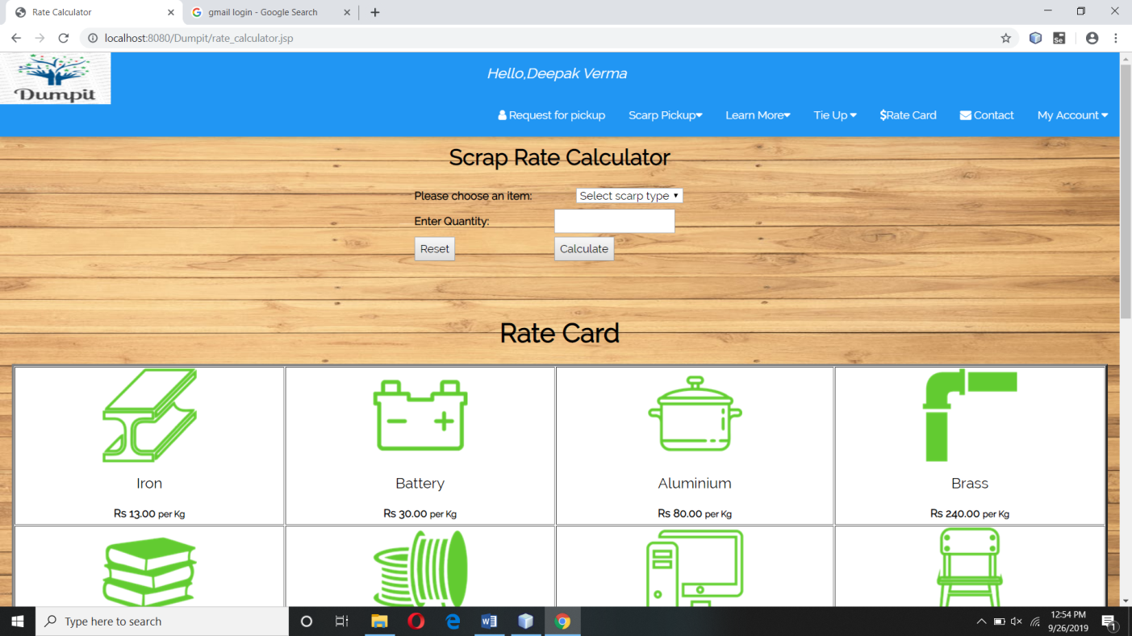

**myprofile.jsp**

<%@page import="java.sql.ResultSet"%>

<%@page import="java.util.Date"%>

<%@page import="java.sql.PreparedStatement"%>

<%@page import="java.sql.DriverManager"%>

<%@page import="java.sql.Connection"%>

<%@page contentType="text/html" pageEncoding="UTF-8"%>

<!DOCTYPE html>

<html>

<title>My Profile</title>

<meta charset="UTF-8">

<meta name="viewport" content="width=device-width, initial-scale=1">

<link rel="stylesheet" href="project.css">

<link rel="stylesheet" href="https://fonts.googleapis.com/css?family=Raleway">

<link rel="stylesheet" href="https://cdnjs.cloudflare.com/ajax/libs/font-awesome/4.7.0/css/font-awesome.min.css">

<style>

body,h1,h2,h3,h4,h5,h6 {font-family: "Raleway", sans-serif}

body, html {

height: 100%;

line-height: 1.8;

background-image: url("./images/background.jpeg");

background-size: 100% 100%;

}

#customers {

font-family: "Trebuchet MS", Arial, Helvetica, sans-serif;

border-collapse: collapse;

}

#customers td, #customers th {

border: 1px solid #ddd;

padding: 8px;

}

#customers tr:nth-child(even){background-color: #f2f2f2;}

#customers tr:hover {background-color: #ddd;}

#customers th {

padding-top: 12px;

padding-bottom: 12px;

text-align: left;

}

</style>

<body >

<% if(session.getAttribute("user")==null && session.getAttribute("vendor")==null && session.getAttribute("admin")==null){

response.sendRedirect("login.jsp");

}

%>

<!-- Navbar (sit on top) -->

<%

boolean flag= false;

if(session.getAttribute("vendor")!=null)

{ flag=true;

%>

<jsp:include page="vendor_header.jsp"/>

<%}%>

<%

if(session.getAttribute("user")!=null)

{flag=true;

%>

<jsp:include page="user_header.jsp"/>

<%}%>

<%

if(session.getAttribute("admin")!=null)

{flag=true;

%>

<jsp:include page="admin_header.jsp"/>

<%}%>

<% if(flag==false)

{%>

<jsp:include page="home_header.jsp"/>

<%}%><br><br><br><br>

<%

if(session.getAttribute("admin")!=null)

{

%>

<center><h1><strong>I am Admin</strong></h1></center>

<%}else {%>

<center><h1><strong>My Profile</strong></h1></center>

<% if(session.getAttribute("user")!= null){

String email=session.getAttribute("user").toString();

try{

Class.forName("com.mysql.jdbc.Driver");

Connection con= DriverManager.getConnection("jdbc:mysql://localhost:3306/dumpit","root","");

PreparedStatement ps=con.prepareStatement("select * from user_detail where e_mail like '"+email+"'");

ResultSet rs=ps.executeQuery();

while(rs.next()){

%>

<table border="5" id="customers" bordercolor="#272785" align="center" width="40%" bgcolor="#FBFBFB" >

<tr>

<th>Name</th><td><%=rs.getString("name") %></td></tr>

<th>Email_id</th><td><%=rs.getString("e_mail") %></td></tr>

<th>Phone no</th><td><%=rs.getString("phone") %></td></tr>

<th>address</th><td><%=rs.getString("address") %></td></tr>

<th>Gender</th><td><%=rs.getString("gender") %></td></tr>

<th>Date of birth</th><td><%=rs.getString("dob") %></td></tr>

<th>City</th><td><%=rs.getString("city") %></td></tr>

<tr>

<td colspan="2">

<center><a href="delete.jsp?remove&d=<%=rs.getString("e_mail")%>" ><i class="w3-button w3-red">Delete my Account</i></a>

&nbsp;&nbsp;&nbsp;&nbsp;&nbsp;&nbsp;&nbsp;&nbsp;&nbsp;&nbsp;&nbsp;&nbsp;&nbsp;&nbsp;&nbsp;&nbsp;

<a href="update.jsp?edit&email=<%=rs.getString("e_mail")%>"><i class="w3-button w3-green">&nbsp;&nbsp;&nbsp;&nbsp;Edit&nbsp;&nbsp;&nbsp;&nbsp;&nbsp;</i></a>

</center></td>

<%

}

}catch(Exception ex){out.print(ex);}

}

%>

</center></table>

<!----------------------------------------------vendor profile------------------------------------------------>

<% if(session.getAttribute("vendor")!= null)

{

String email= session.getAttribute("vendor").toString();

try{

Class.forName("com.mysql.jdbc.Driver");

Connection con= DriverManager.getConnection("jdbc:mysql://localhost:3306/dumpit","root","");

PreparedStatement ps=con.prepareStatement("select * from vendor_detail where e_mail like '"+email+"'");

ResultSet rs=ps.executeQuery();

while(rs.next()){

%>

<table border="5" id="customers" bordercolor="#272785" align="center" width="40%" bgcolor="#FBFBFB" >

<tr><th>Name</th><td><%=rs.getString("name") %></td></tr>

<tr><th>Email_id</th><td><%=rs.getString("e_mail") %></td></tr>

<tr><th>Phone no</th><td><%=rs.getString("phone") %></td></tr>

<tr><th>address</th><td><%=rs.getString("address") %></td></tr>

<tr><th>Gender</th><td><%=rs.getString("gender") %></td></tr>

<tr><th>Date of birth</th><td><%=rs.getString("dob") %></td></tr>

<tr><th>City</th><td><%=rs.getString("city") %></td></tr>

<tr><td colspan="2">

<center><a href="delete.jsp?vendorremove&d=<%=rs.getString("e_mail")%>" ><i class="w3-button w3-red">Delete my Account</i></a>

&nbsp;&nbsp;&nbsp;&nbsp;&nbsp;&nbsp;&nbsp;&nbsp;&nbsp;&nbsp;&nbsp;&nbsp;&nbsp;&nbsp;&nbsp;&nbsp;

<a href="update.jsp?vendoredit&email=<%=rs.getString("e_mail")%>"><i class="w3-button w3-green">&nbsp;&nbsp;&nbsp;&nbsp;Edit&nbsp;&nbsp;&nbsp;&nbsp;&nbsp;</i></a>

</td></center></tr>

<%

}

}

catch(Exception ex){out.print(ex);}

}

%>

</center></table>

<%}%>

<br><br><br><br><br><br><br><br><br><br><br><br><br><br><br><br><br><br>

<!-- Footer -->

<jsp:include page="footer.jsp" ></jsp:include>

<script>

// Modal Image Gallery

function onClick(element) {

document.getElementById("img01").src = element.src;

document.getElementById("modal01").style.display = "block";

var captionText = document.getElementById("caption");

captionText.innerHTML = element.alt;

}

// Toggle between showing and hiding the sidebar when clicking the menu icon

var mySidebar = document.getElementById("mySidebar");

function w3_open() {

if (mySidebar.style.display === 'block') {

mySidebar.style.display = 'none';

} else {

mySidebar.style.display = 'block';

}

}

// Close the sidebar with the close button

function w3_close() {

mySidebar.style.display = "none";

}

</script>

</body>

</html>

**Output:-**

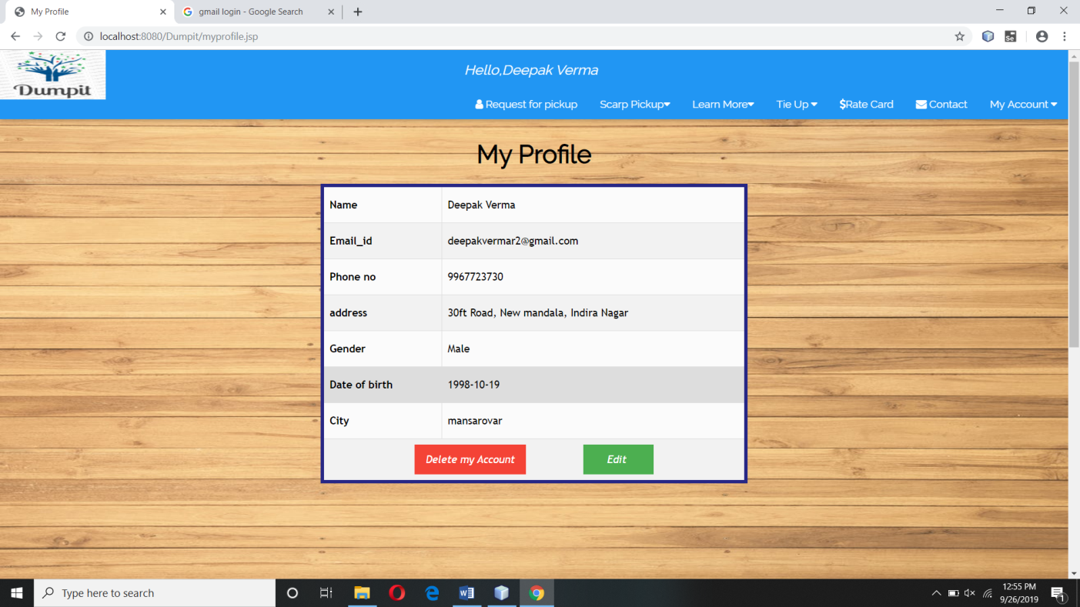

**Logout.jsp**

<%--

Document : logout

Created on : Sep 7, 2019, 11:05:16 PM

Author : Sandip

--%>

<%@page contentType="text/html" pageEncoding="UTF-8"%>

<!DOCTYPE html>

<html>

<head>

<meta http-equiv="Content-Type" content="text/html; charset=UTF-8">

<title>Logout</title>

</head>

<body>

<%

session.removeAttribute("user");

session.removeAttribute("admin");

session.removeAttribute("vendor");

response.sendRedirect("Home.jsp");

%>

</body>

</html>

**vendor_home.jsp**

<%@page import="java.security.MessageDigest"%>

<%@page import="java.sql.ResultSet"%>

<%@page import="java.util.Date"%>

<%@page import="java.sql.PreparedStatement"%>

<%@page import="java.sql.DriverManager"%>

<%@page import="java.sql.Connection"%>

<html>

<!DOCTYPE html>

<html>

<title>Vendor Home</title>

<meta charset="UTF-8">

<meta name="viewport" content="width=device-width, initial-scale=1">

<link rel="stylesheet" href="project.css">

<link rel="stylesheet" href="https://fonts.googleapis.com/css?family=Raleway">

<link rel="stylesheet" href="https://cdnjs.cloudflare.com/ajax/libs/font-awesome/4.7.0/css/font-awesome.min.css">

<style>

body,h1,h2,h3,h4,h5,h6 {font-family: "Raleway", sans-serif}

body, html {

height: 100%;

line-height: 1.8;

background-image: url("./images/background.jpeg");

background-size: 100% 100%;

}

#customers {

font-family: "Trebuchet MS", Arial, Helvetica, sans-serif;

border-collapse: collapse;

}

#customers td, #customers th {

border: 1px solid #ddd;

padding: 8px;

}

#customers tr:nth-child(even){background-color: #f2f2f2;}

#customers tr:hover {background-color: #ddd;}

#customers th {

padding-top: 12px;

padding-bottom: 12px;

text-align: left;

background-color: #4CAF50;

color: white;

}

</style>

<body >

<% if(session.getAttribute("user")==null && session.getAttribute("vendor")==null && session.getAttribute("admin")==null){

response.sendRedirect("login.jsp");

} %>

<!-- Navbar (sit on top) -->

<jsp:include page="vendor_header.jsp"/>

<!-- servives --><br><br><header class="w3-container" style="padding-top:22px">

<h1><b><i class="fa fa-dashboard"></i> My Dashboard</b></h1>

</header>

<form action="add.jsp" method="post">

<div class="w3-row-padding w3-margin-bottom">

<div class="w3-quarter ">

<div class="w3-clear w3-center w3-padding-16">

<button class="w3-red w3-text-white" name="payment" ><h4>Make Payment</h4>

</div>

</div>

</form>

<form action="output.jsp" method="post">

<div class="w3-quarter ">

<div class="w3-clear w3-center w3-padding-16">

<button class="w3-red w3-text-white" name="pickup_request" ><h4>Pickup Request's</h4>

</div>

</div>

</form>

<form action="output.jsp" method="post">

<div class="w3-quarter ">

<div class="w3-clear w3-center w3-padding-16">

<button class="w3-red w3-text-white" name="total_scarp" ><h4>Show Total Scarp Available</h4>

</div>

</div>

</form

</div>

<br><br><br><br>

<%

try{

%>

<strong><center><h2>Pickup Request's</h2></center></strong>

<table border="5" id="customers" bordercolor="#272785" align="center" bgcolor="#FBFBFB" >

<tr>

<th>Id</th>

<th>Name</th>

<th>Mobile no</th>

<th>Alternate Mobile no</th>

<th>Email_id</th>

<th>address</th>

<th>city</th>

<th>Scarp name</th>

<th>Scarp weight</th>

<th>Requested Date</th>

<th>Pick up Date</th>

<th>Status</th>

<th>Action</th>

</tr>

<%

Class.forName("com.mysql.jdbc.Driver");

Connection con= DriverManager.getConnection("jdbc:mysql://localhost:3306/dumpit","root","");

PreparedStatement ps=con.prepareStatement("select * from request");

ResultSet rs=ps.executeQuery();

while(rs.next()){

%><tr>

<td><%=rs.getString("id") %></td>

<td><%=rs.getString("name") %></td>

<td><%=rs.getString("mobile") %></td>

<td><%=rs.getString("alternate_moblie")%></td>

<td><%=rs.getString("email") %></td>

<td><%=rs.getString("address") %></td>

<td><%=rs.getString("city") %></td>

<td><%=rs.getString("scarp_name") %></td>

<td><%=rs.getString("scarp_weight") %></td>

<td><%=rs.getString("request_date") %></td>

<td><%=rs.getString("pickup_date") %></td>

<td><%=rs.getString("status") %></td>

<td class="w3-text-center">

<a href="delete.jsp?accept&d=<%=rs.getString("id")%>"><i class="w3-button w3-yellow">Accepted</i></a>

<br><br>

<a href="delete.jsp?done&d=<%=rs.getString("id")%>" ><i class="w3-button w3-green">Done</i></a>

</td>

</tr>

<%

}

}

catch(Exception ex){

out.print(ex);

}

%>

</center></table><br><br><br>

<strong><center><h2>Total Scarp Available</h2></center></strong>

<table border="5" id="customers" bordercolor="#272785" align="center" bgcolor="#FBFBFB" >

<tr>

<th>Scarp Name</th>

<th>Total_Weight</th>

</tr>

<%

try{ Class.forName("com.mysql.jdbc.Driver");

Connection con= DriverManager.getConnection("jdbc:mysql://localhost:3306/dumpit","root","");

PreparedStatement ps=con.prepareStatement("SELECT scarp_name, sum(scarp_weight) from request group by scarp_name;");

ResultSet rs=ps.executeQuery();

while(rs.next()){

%><tr>

<td><%=rs.getString("scarp_name") %></td>

<td><%=rs.getString("sum(scarp_weight)") %></td>

</tr>

<%

}

}

catch(Exception ex){

out.print(ex);

}

%>

</table>

<br><br><br><br><br><br><br><br><br><br><br><br><br><br><br><br><br><br>

<!-- Footer -->

<jsp:include page="footer.jsp" ></jsp:include>

<script>

// Modal Image Gallery

function onClick(element) {

document.getElementById("img01").src = element.src;

document.getElementById("modal01").style.display = "block";

var captionText = document.getElementById("caption");

captionText.innerHTML = element.alt;

}

// Toggle between showing and hiding the sidebar when clicking the menu icon

var mySidebar = document.getElementById("mySidebar");

function w3_open() {

if (mySidebar.style.display === 'block') {

mySidebar.style.display = 'none';

} else {

mySidebar.style.display = 'block';

}

}

// Close the sidebar with the close button

function w3_close() {

mySidebar.style.display = "none";

}

</script>

</body>

</html>

**Output:-**

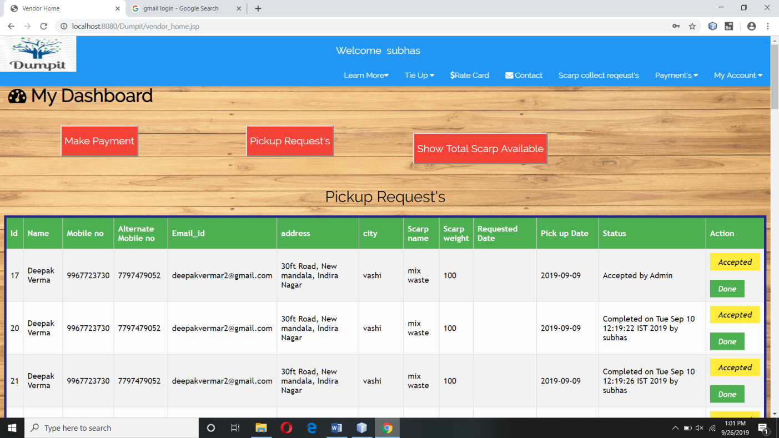

**Add.jsp**

**Code:-**

<%@page import="java.security.MessageDigest"%>

<%@page import="java.sql.ResultSet"%>

<%@page import="java.util.Date"%>

<%@page import="java.sql.PreparedStatement"%>

<%@page import="java.sql.DriverManager"%>

<%@page import="java.sql.Connection"%>

<!DOCTYPE html>

<html>

<title>Add</title>

<meta charset="UTF-8">

<meta name="viewport" content="width=device-width, initial-scale=1">

<link rel="stylesheet" href="project.css">

<link rel="stylesheet" href="https://fonts.googleapis.com/css?family=Raleway">

<link rel="stylesheet" href="https://cdnjs.cloudflare.com/ajax/libs/font-awesome/4.7.0/css/font-awesome.min.css">

<style>

body,h1,h2,h3,h4,h5,h6 {font-family: "Raleway", sans-serif}

body, html {

height: 100%;

line-height: 1.8;

background-image: url("./images/background.jpeg");

background-size: 100% 100%;

}

#customers {

font-family: "Trebuchet MS", Arial, Helvetica, sans-serif;

border-collapse: collapse;

}

#customers td, #customers th {

border: 1px solid #ddd;

padding: 8px;

}

#customers tr:nth-child(even){background-color: #f2f2f2;}

#customers tr:hover {background-color: #ddd;}

#customers th {

padding-top: 12px;

padding-bottom: 12px;

text-align: left;

}

</style>

<body>

<% if(session.getAttribute("user")==null && session.getAttribute("vendor")==null && session.getAttribute("admin")==null){

response.sendRedirect("login.jsp");

} %>

<!-- Navbar (sit on top) -->

<%

boolean flag= false;

if(session.getAttribute("vendor")!=null)

{ flag=true;

%>

<jsp:include page="vendor_header.jsp"/>

<%}%>

<%

if(session.getAttribute("user")!=null)

{flag=true;

%>

<jsp:include page="user_header.jsp"/>

<%}%>

<%

if(session.getAttribute("admin")!=null)

{flag=true;

%>

<jsp:include page="admin_header.jsp"/>

<%}%>

<% if(flag==false)

{%>

<jsp:include page="home_header.jsp"/>

<%}%>

<!--Registration-->

<br><br><br><br>

<!---------------------------------Add Vendor----------------->

<% if(request.getParameter("addvendor")!=null)

{ %>

<form action="add.jsp" method="post" >

<table border="5" bordercolor="#272785" align="center" width="41%" bgcolor="#FBFBFB" >

<caption><strong><h2>Add Vendor</strong></h2></caption>

<tr>

<th>Enter your name</th>

<td><center><input type="text" name="name" id="name" maxlength="10" title="enter vendor's first name" placeholder=" Enter your name" required/></td>

</center>

</tr>

<tr>

<th>Enter your password</th>

<td><center><input type="password" placeholder=" Enter password" name="pass" required/></td>

</center>

</tr>

<tr>

<th>ReEnter your password</th>

<td><center><input type="password" placeholder=" Plz Re-enter your password" required/></td>

</center>

</tr>

<tr>

<th>Enter your email</th>

<td><center><input type="email" placeholder=" Enter vendor's email" name="email_id" required/></td>

</center>

</tr>

<tr>

<th>Enter your mobile</th>

<td><center><input type="text" pattern="[0-9]{8-10}" title="Enter proper mobile no." placeholder=" Enter vendor's Mobile no." name="mobile" required/></td>

</center>

</tr>

<tr>

<th>Enter your address</th>

<td><center><textarea rows="4" cols="20" name="address"></textarea></td>

</center>

</tr>

<tr>

<th>Select your City</th>

<td><center>

<select name="city" required>

<option value="" selected="selected" disabled="disabled">Select your City</option>

<option value="vashi">vashi</option>

<option value="govandi">govandi</option>

<option value="mansarovar">mansarovar</option>

<option value="belapur">belapur</option>

<option value="bandra">bandra</option>

<option value="2">mankhurd</option>

<option value="2">chembur</option>

<option value="2">kurla</option>

<option value="2">sanpada</option>

<option value="2">nerul</option>

<option value="2">panvel</option>

</select>

</center>

</td>

</tr>

<tr>

<th>Select your gender</th>

<td><center>

Male<input type="radio" name="gender" value="Male"/>

Female<input type="radio" name="gender" value="Female"/>

</center>

</td>

</tr>

<tr>

<th>Select your DOB</th>

<td><center><input type="date" placeholder="MM/DD/YYYY" name="dob" required/></td>

</center>

</tr>

<tr>

<td colspan="2" align="center"><input type="submit" name="add" value="Add"/>

<input type="reset" value="Reset Data"/>

</td>

</tr>

</table>

</form>

<br><br>

<%}%>

<!--------------------------------------------Add Payment----------------------------------------->

<% if(request.getParameter("payment")!=null)

{ %>

<br><br>

<form action="add.jsp" method="post" >

<table border="5" id="customers" bordercolor="#272785" method="post"align="center" width="41%" bgcolor="#FBFBFB" >

<caption><strong><h2>Enter Payment Details</strong></h2></caption>

<tr>

<th>Enter Scrap Type</th>

<td><center>

<select name="scrap_type" required>

<option value="" >Select scarp type</option>

<%

try{

Class.forName("com.mysql.jdbc.Driver");

Connection con= DriverManager.getConnection("jdbc:mysql://localhost:3306/dumpit","root","");

PreparedStatement ps=con.prepareStatement("select * from rate");

ResultSet rs=ps.executeQuery();

while(rs.next()){

%>

<option value="<%=rs.getString("name") %>"><%=rs.getString("name") %></option>

<%}

}catch(Exception ex){

out.print("<script>alert('"+ex+"')</script>");

}

%>

</select>

</center>

</td>

</tr>

<tr>

<th>Enter Scrap Weight </th>

<td><center>

<input type="text" name="weight" placeholder="Enter Weight in KG" />

</td>

</center>

</tr>

<tr>

<th>Enter Amount</th>

<td><center><input type="number" name="amount" titel="Enter proper Amount" placeholder="Enter Amount." required/></td>

</center>

</tr>

<tr>

<th>Select user Email Id</th>

<td><center>

<select name="user_email" required>

<option value="" >Select User Email Id</option>

<%

try{

Class.forName("com.mysql.jdbc.Driver");

Connection con= DriverManager.getConnection("jdbc:mysql://localhost:3306/dumpit","root","");

PreparedStatement ps=con.prepareStatement("select distinct email from request");

ResultSet rs=ps.executeQuery();

while(rs.next()){

%>

<option value="<%=rs.getString("email") %>"><%=rs.getString("email") %></option>

<%}

}catch(Exception ex){

out.print("<script>alert('"+ex+"')</script>");

}

%>

</select>

</center>

</td>

</tr>

<tr>

<th>Select your City</th>

<td><center>

<select name="city" required>

<option value="" selected="selected" disabled="disabled">Select your City</option>

<option value="vashi">vashi</option>

<option value="govandi">govandi</option>

<option value="mansarovar">mansarovar</option>

<option value="belapur">belapur</option>

<option value="bandra">bandra</option>

<option value="mankhurd">mankhurd</option>

<option value="chembur">chembur</option>

<option value="kurla">kurla</option>

<option value="sanpada">sanpada</option>

<option value="nerul">nerul</option>

<option value="panvel">panvel</option>

</select>

</center>

</td>

</tr>

<tr>

<td colspan="2" align="center"><input type="submit" name="pay" value="Make Payment"/>

<input type="reset" value="Reset Data"/>

</td>

</tr>

</table>

</form>

<br><br><br><br><br><br><br><br><br><br><br><br>

<%}%>

<!--------------------------------------------Add Scarp-------------------------------------------------------->

<% if(request.getParameter("addscarp")!=null)

{ %>

<br><br>

<form action="add.jsp" method="post" >

<table border="5" id="customers" bordercolor="#272785" method="post"align="center" width="41%" bgcolor="#FBFBFB" >

<caption><strong><h2>Add Scrap</strong></h2></caption>

<tr>

<th>Enter Scrap Type</th>

<td><center><input type="text" name="name" placeholder=" Enter Scrap name" required/></td>

</center>

</tr>

<tr>

<tr>

<th>Enter Amount</th>

<td><center><input type="text" pattern="[0-9]{0-5}" name="amount" titel="Enter proper Amount" placeholder="Enter Amount." required/></td>

</center>

</tr>

<tr>

<th>Select Image</th>

<td><center><input type="file" name="image" accept="image/*" </center></td>

</tr>

<tr>

<td colspan="2" align="center"><input type="submit" name="add_scarp" value="Add Scarp"/>

<input type="reset" value="Reset Data"/>

</td>

</tr>

</table>

</form>

<br><br><br><br><br><br><br><br><br><br><br><br>

<%

}

%>

<!------------------------------------- ------------------------------------------->

<!-- Footer -->

<jsp:include page="footer.jsp" ></jsp:include>

<script>

// Modal Image Gallery

function onClick(element) {

document.getElementById("img01").src = element.src;

document.getElementById("modal01").style.display = "block";

var captionText = document.getElementById("caption");

captionText.innerHTML = element.alt;

}

// Toggle between showing and hiding the sidebar when clicking the menu icon

var mySidebar = document.getElementById("mySidebar");

function w3_open() {

if (mySidebar.style.display === 'block') {

mySidebar.style.display = 'none';

} else {

mySidebar.style.display = 'block';

}

}

// Close the sidebar with the close button

function w3_close() {

mySidebar.style.display = "none";

}

</script>

</body>

</html>

<!-------------Add scarp code-------------------------------->

<%

if(request.getParameter("add_scarp")!=null){

try{

String name=request.getParameter("name");

int amount=Integer.parseInt(request.getParameter("amount"));

String image=request.getParameter("image");

Class.forName("com.mysql.jdbc.Driver");

Connection con= DriverManager.getConnection("jdbc:mysql://localhost:3306/dumpit","root","");

PreparedStatement ps=con.prepareStatement("insert into rate values(?,?,?)");

ps.setString(1, name);

ps.setInt(2, amount);

ps.setString(3,image);

int i=ps.executeUpdate();

if(i>0){

out.println("<script>alert('New Scarp Saved Successfully');window.location.assign('admin_home.jsp');</script>");

}

else{

out.println("<script>alert('Some Thing went wrong try again'); window.location.assign('admin_home.jsp?add_scarp');</script>");

}

}catch(Exception ex){

out.print(ex);

out.println("<script>alert('"+ex+"')</script>");

}

}

%>

<!-----------------------------------------Add Payment code--------->

<%

if(request.getParameter("pay")!=null){

try{

String scrap_type=request.getParameter("scrap_type");

String email=request.getParameter("user_email");

String amount=request.getParameter("amount");

String city=request.getParameter("city");

String weight=request.getParameter("weight");

String vendor_email = session.getAttribute("vendor").toString();

Class.forName("com.mysql.jdbc.Driver");

Connection con= DriverManager.getConnection("jdbc:mysql://localhost:3306/dumpit","root","");

PreparedStatement ps=con.prepareStatement("insert into payment values(?,?,?,?,?,?,?)");

ps.setString(1, vendor_email);

ps.setString(2, scrap_type);

ps.setString(3,weight);

ps.setString(4,amount);

ps.setString(5, email);

ps.setString(6, city);

ps.setString(7, ""+new java.util.Date()+"");

int i=ps.executeUpdate();

if(i>0)

{

out.println("<script>alert('Payment done successfully');window.location.assign('add.jsp?payment');</script>");

}

else

{

out.println("<script>alert('Some Thing went wrong try again');window.location.assign('add.jsp?payment');</script>");

}

}catch(Exception ex){

out.println("<script>alert('"+ex+"');</script>");

}

finally{

//

}

}

%>

<!--------------------------------------Add vendor Code--------------------------------------------->

<%

if(request.getParameter("add")!=null){

try{

String name=request.getParameter("name");

String pass=request.getParameter("pass");

String selectedcity=request.getParameter("city");

String email=request.getParameter("email_id");

String mobile=request.getParameter("mobile");

String address=request.getParameter("address");

String gender=request.getParameter("gender");

String dob=request.getParameter("dob");

//----------MD5 Implementation--------------------------------------------------------

MessageDigest mdAlgorithm = MessageDigest.getInstance("MD5");

mdAlgorithm.update(pass.getBytes());

byte[] digest = mdAlgorithm.digest();

StringBuffer hexString = new StringBuffer();

for (int i = 0; i < digest.length; i++) {

pass = Integer.toHexString(0xFF & digest[i]);

if (pass.length() < 2) {

pass = "0" + pass;

}

hexString.append(pass);

}

String password =hexString.toString();

out.println("ere");

Class.forName("com.mysql.jdbc.Driver");

Connection con= DriverManager.getConnection("jdbc:mysql://localhost:3306/dumpit","root","");

PreparedStatement ps=con.prepareStatement("insert into vendor_detail values(?,?,?,?,?,?,?)");

ps.setString(1,name);

ps.setString(2, email);

ps.setString(3, mobile);

ps.setString(4, address);

ps.setString(5, gender);

ps.setString(6,dob);

ps.setString(7, selectedcity);

int i=ps.executeUpdate();

if(i>0)

{

PreparedStatement login=con.prepareStatement("insert into vendor_login values(?,?)");

login.setString(1, email);

login.setString(2,password);

login.executeUpdate();

out.println("<script>alert('Vendor Added succesfully');window.location.assign('admin_home.jsp');</script>");

}

else

{

out.print("<script>alert('Some Thing wnt wrong try again');window.location.assign('admin_home.jsp?add');</script>");

}

// response.sendRedirect("admin_home.jsp");

}catch(Exception ex){

out.print("<script>alert('"+ex+"');</script>");

}

// finally{

// response.sendRedirect("admin_home.jsp");

// }

}

%>

**Output:-**

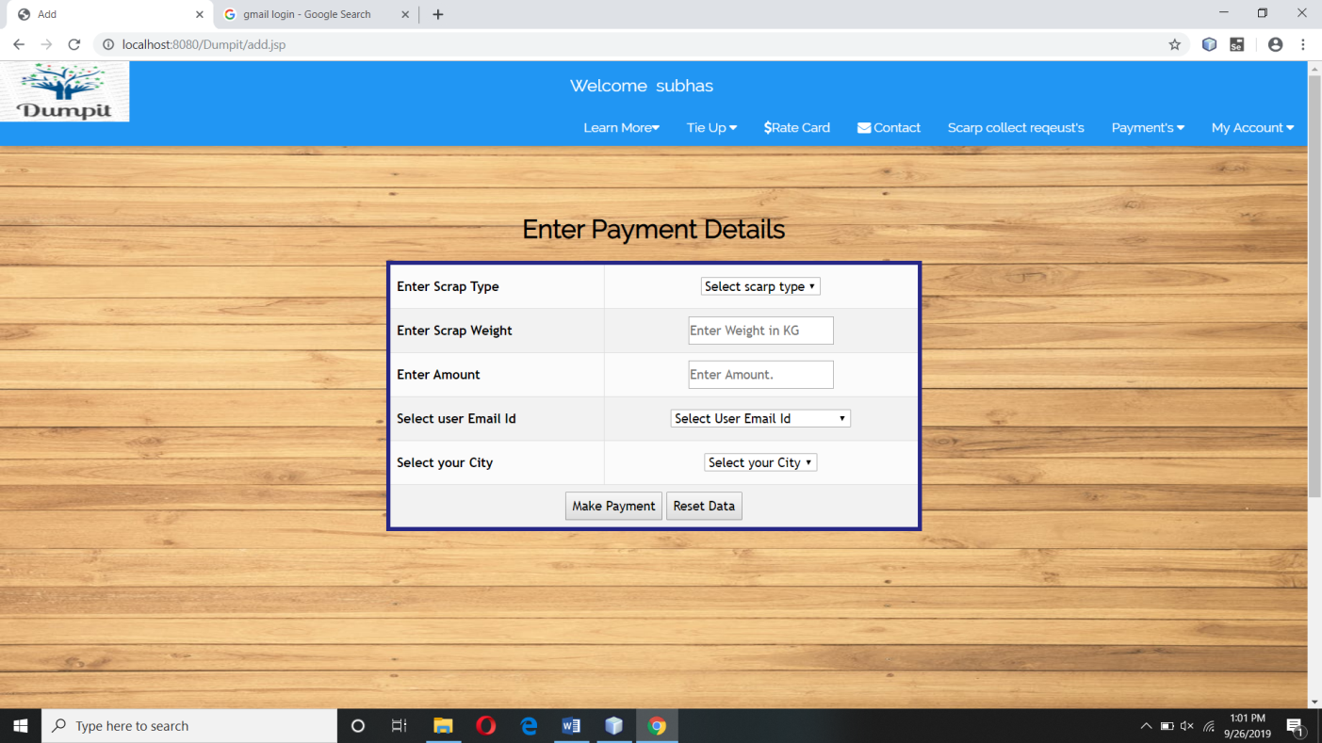

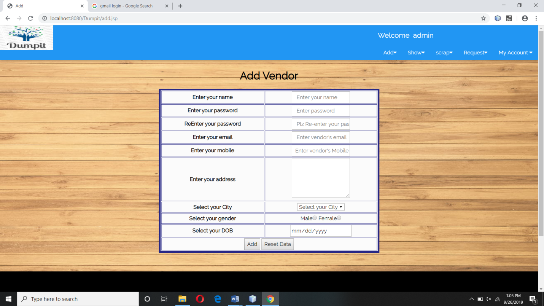

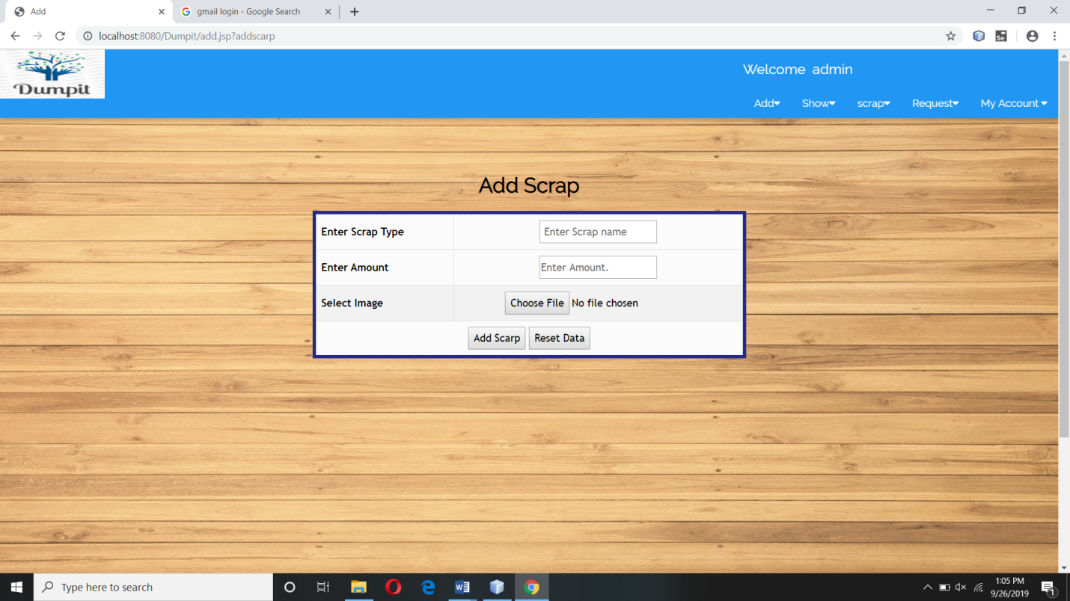

**Admin_home.jsp**

<!DOCTYPE html>

<html>

<title>Admin Dashboard</title>

<meta charset="UTF-8">

<meta name="viewport" content="width=device-width, initial-scale=1">

<link rel="stylesheet" href="project.css">

<link rel="stylesheet" href="https://fonts.googleapis.com/css?family=Raleway">

<link rel="stylesheet" href="https://cdnjs.cloudflare.com/ajax/libs/font-awesome/4.7.0/css/font-awesome.min.css">

<style>

body,h1,h2,h3,h4,h5,h6 {font-family: "Raleway", sans-serif}

body, html {

height: 100%;

line-height: 1.8;

background-image:url("./images/background.jpeg");

background-attachment:fixed;

background-size:100% 100%;

}

.w3-bar .w3-button {

padding: 16px;

}

.w3-container{background-image: url("./images/background.jpeg");}

</style>

<body >

<% if(session.getAttribute("user")==null && session.getAttribute("vendor")==null && session.getAttribute("admin")==null){

response.sendRedirect("login.jsp");

} %>

<!-- Navbar (sit on top) -->

<%

boolean flag= false;

if(session.getAttribute("vendor")!=null)

{ flag=true;

%>

<jsp:include page="vendor_header.jsp"/>

<%}%>

<%

if(session.getAttribute("user")!=null)

{flag=true;

%>

<jsp:include page="user_header.jsp"/>

<%}%>

<%

if(session.getAttribute("admin")!=null)

{flag=true;

%>

<jsp:include page="admin_header.jsp"/>

<%}%>

<% if(flag==false)

{%>

<jsp:include page="home_header.jsp"/>

<%}%>

<%if(session.getAttribute("admin")==null){

response.sendRedirect("login.jsp");

}%>

<!-- servives --><br><br><h1><b><i class="fa fa-dashboard"></i> My Dashboard</b></h1>

<br>

<center><form action="search.jsp" method="post">

Enter Email_id :-<input type="text" name="Email_id">&nbsp;&nbsp;&nbsp;

&nbsp;&nbsp;&nbsp;&nbsp;&nbsp;&nbsp;&nbsp;&nbsp;&nbsp;&nbsp;&nbsp;&nbsp;

&nbsp;&nbsp;&nbsp;&nbsp;&nbsp;&nbsp;&nbsp;&nbsp;&nbsp;

<input type="submit" name="search" value="Search"></form>

<br><br>

</center>

<form action="add.jsp" method="post">

<div class="w3-row-padding w3-margin-bottom">

<div class="w3-quarter ">

<div class="w3-clear w3-center w3-padding-16">

<button class="w3-red w3-text-white" name="addvendor" ><h4>Add Vendor</h4>

</div>

</div>

<div class="w3-quarter ">

<div class="w3-clear w3-center w3-padding-16">

<button class="w3-red w3-text-white" type="submit" name="addscarp" ><h4>Add Scrap</h4></a>

</div>

</div>

</form>

<form action="output.jsp" method="post">

<div class="w3-quarter ">

<div class="w3-clear w3-center w3-padding-16">

<button class="w3-red w3-text-white" type="submit" name="user_details" ><h4>Show Customer Details</h4></a>

</div>

</div>

<div class="w3-quarter ">

<div class="w3-clear w3-center w3-padding-16">

<button class="w3-red w3-text-white" type="submit" name="message" ><h4>Show Messages</h4></a>

</div>

</div>

<div class="w3-quarter ">

<div class="w3-clear w3-center w3-padding-16">

<button class="w3-red w3-text-white" type="submit" name="payment" ><h4>Show payment Details</h4></a>

</div>

</div>

<div class="w3-quarter ">

<div class="w3-clear w3-center w3-padding-16">

<button class="w3-red w3-text-white" type="submit" name="vendor_detail" ><h4>Show Vendor Details</h4></a>

</div>

</div><div class="w3-quarter ">

<div class="w3-clear w3-center w3-padding-16">

<button class="w3-red w3-text-white" type="submit" name="pickup_request" ><h4>Show Scarp Collect Request</h4></a>

</div>

</div>

<div class="w3-quarter ">

<div class="w3-clear w3-center w3-padding-16">

<button class="w3-red w3-text-white" type="submit" name="totalpayment" ><h4>Total Stock Available</h4></a>

</div>

</div>

</div></form>

<br><br><br><br><br><br><br><br><br><br><br><br><br><br><br><br><br><br>

<!-- Footer -->

<jsp:include page="footer.jsp"/>

<script>

// Modal Image Gallery

function onClick(element) {

document.getElementById("img01").src = element.src;

document.getElementById("modal01").style.display = "block";

var captionText = document.getElementById("caption");

captionText.innerHTML = element.alt;

}

// Toggle between showing and hiding the sidebar when clicking the menu icon

var mySidebar = document.getElementById("mySidebar");

function w3_open() {

if (mySidebar.style.display === 'block') {

mySidebar.style.display = 'none';

} else {

mySidebar.style.display = 'block';

}

}

// Close the sidebar with the close button

function w3_close() {

mySidebar.style.display = "none";

}

</script>

</body>

</html>

**Output:-**

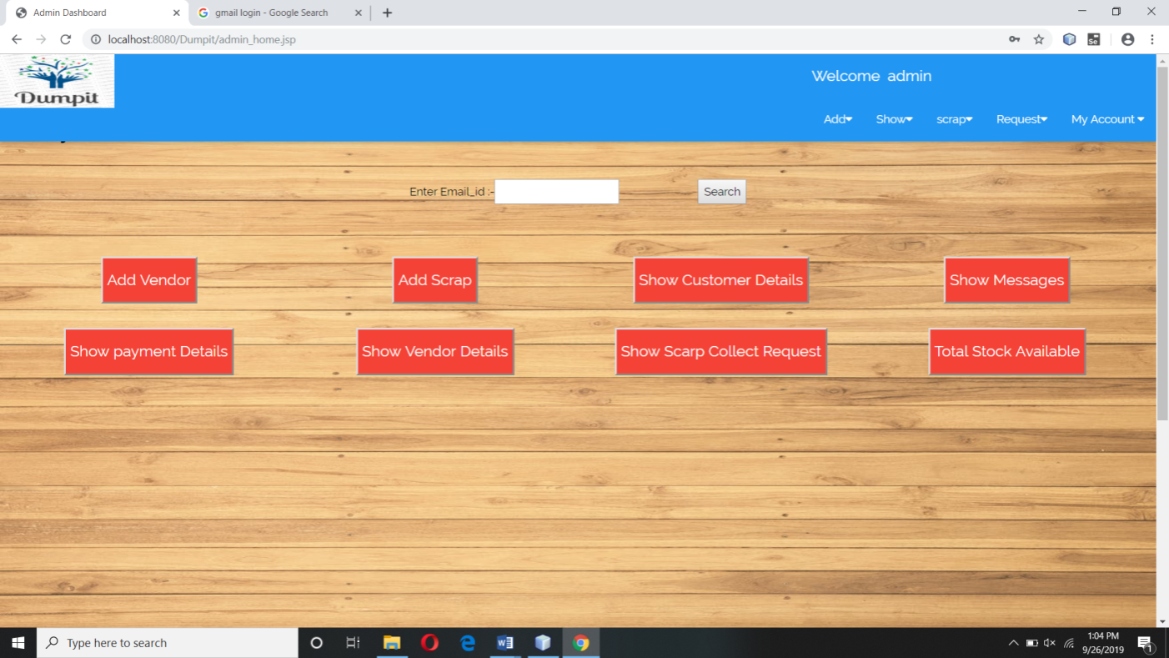

**Output.jsp**

**Code:-**

<%@page import="java.sql.ResultSet"%>

<%@page import="java.util.Date"%>

<%@page import="java.sql.PreparedStatement"%>

<%@page import="java.sql.DriverManager"%>

<%@page import="java.sql.Connection"%>

<%@page contentType="text/html" pageEncoding="UTF-8"%>

<!DOCTYPE html>

<html>

<title>Result</title>

<meta charset="UTF-8">

<meta name="viewport" content="width=device-width, initial-scale=1">

<link rel="stylesheet" href="project.css">

<link rel="stylesheet" href="https://fonts.googleapis.com/css?family=Raleway">

<link rel="stylesheet" href="https://cdnjs.cloudflare.com/ajax/libs/font-awesome/4.7.0/css/font-awesome.min.css">

<style>

body,h1,h2,h3,h4,h5,h6 {font-family: "Raleway", sans-serif}

body, html {

height: 100%;

line-height: 1.8;

background-image: url("./images/background.jpeg");

background-size: 100% 100%;

}

#customers {

font-family: "Trebuchet MS", Arial, Helvetica, sans-serif;

border-collapse: collapse;

}

#customers td, #customers th {

border: 1px solid #ddd;

padding: 8px;

}

#customers tr:nth-child(even){background-color: #f2f2f2;}

#customers tr:hover {background-color: #ddd;}

#customers th {

padding-top: 12px;

padding-bottom: 12px;

text-align: left;

background-color: #4CAF50;

color: white;

}

</style>

<body >

<% if(session.getAttribute("user")==null && session.getAttribute("vendor")==null && session.getAttribute("admin")==null){

response.sendRedirect("login.jsp");

} %>

<!-- Navbar (sit on top) -->

<%

boolean flag= false;

if(session.getAttribute("vendor")!=null)

{ flag=true;

%>

<jsp:include page="vendor_header.jsp"/>

<%}%>

<%

if(session.getAttribute("user")!=null)

{flag=true;

%>

<jsp:include page="user_header.jsp"/>

<%}%>

<%

if(session.getAttribute("admin")!=null)

{flag=true;

%>

<jsp:include page="admin_header.jsp"/>

<%}%>

<% if(flag==false)

{%>

<jsp:include page="home_header.jsp"/>

<%}%>

<!-- servives --><br><br><br><br>

<h1><b><i class="fa fa-dashboard"></i> My Dashboard</b></h1>

<!--------------------------------------User Details---------------------------------------------------------->

<% if(request.getParameter("totalpayment")!=null){ %>

<br><br><br>

<strong><center><h2>Total Payment Detail</h2></center></strong>

<table border="5" id="customers" bordercolor="#272785" width="40%" align="center" bgcolor="#FBFBFB" >

<tr>

<th>Scarp Name</th>

<th>Total_Weight</th>

<th>Total Money Spent</th>

</tr>

<%

try{ Class.forName("com.mysql.jdbc.Driver");

Connection con= DriverManager.getConnection("jdbc:mysql://localhost:3306/dumpit","root","");

PreparedStatement ps=con.prepareStatement("SELECT scrap_types, sum(weight),sum(amount) from payment group by scrap_types;");

ResultSet rs=ps.executeQuery();

while(rs.next()){

%><tr>

<td><%=rs.getString("scrap_types") %></td>

<td><%=rs.getString("sum(weight)") %></td>

<td><%=rs.getString("sum(amount)") %></td>

</tr>

<%

}

}

catch(Exception ex){

out.print(ex);

}

%>

</table>

<% }%>

<%

if(request.getParameter("user_details")!= null){

try{

%>

<strong><center><h2>User Details</h2></center></strong>

<table border="5" id="customers" bordercolor="#272785" align="center" bgcolor="#FBFBFB" >

<tr>

<th>Name</th>

<th>Email_id</th>

<th>Phone no</th>

<th>address</th>

<th>Gender</th>

<th>Date of birth</th>

<th>City</th>

<th>Action</th>

</tr>

<%

Class.forName("com.mysql.jdbc.Driver");

Connection con= DriverManager.getConnection("jdbc:mysql://localhost:3306/dumpit","root","");

PreparedStatement ps=con.prepareStatement("select * from user_detail");

ResultSet rs=ps.executeQuery();

while(rs.next()){

%>

<tr>

<td><%=rs.getString("name") %></td>

<td><%=rs.getString("e_mail") %></td>

<td><%=rs.getString("phone") %></td>

<td><%=rs.getString("address") %></td>

<td><%=rs.getString("gender") %></td>

<td><%=rs.getString("dob") %></td>

<td><%=rs.getString("city") %></td>

<td>

<a href="update.jsp?edit&email=<%=rs.getString("e_mail")%>"><i class="w3-button w3-yellow">Edit</i></a>

<br>

<a href="delete.jsp?remove&d=<%=rs.getString("e_mail")%>" ><i class="w3-button w3-red">Remove</i></a>

<br>

</td>

</tr>

<%

}

}

catch(Exception ex){

out.print(ex);

}

%>

</center></table>

<%}

%>

<!-------------------------------------Messages--------------------------------->

<%

if(request.getParameter("message")!= null){

try{

%>

<strong><center><h2>Messages</h2></center></strong>

<table border="5" id="customers" bordercolor="#272785" align="center" bgcolor="#FBFBFB" >

<tr>

<th>Name</th>

<th>Email_id</th>

<th>address</th>

<th>Subject</th>

<th>Message</th>

</tr>

<%

Class.forName("com.mysql.jdbc.Driver");

Connection con= DriverManager.getConnection("jdbc:mysql://localhost:3306/dumpit","root","");

PreparedStatement ps=con.prepareStatement("select * from contact");

ResultSet rs=ps.executeQuery();

while(rs.next()){

%><tr>

<td><%=rs.getString("name") %></td>

<td><%=rs.getString("e_mail") %></td>

<td><%=rs.getString("address") %></td>

<td><%=rs.getString("subject") %></td>

<td><%=rs.getString("message") %></td>

</tr>

<%

}

}

catch(Exception ex){

out.print(ex);

}

}

%>

<!-----------------------------------payment----------------------------------------------->

<%

if(request.getParameter("payment")!= null){

try{

%>

<strong><center><h2>Payment Details</h2></center></strong>

<table border="5" id="customers" bordercolor="#272785" align="center" bgcolor="#FBFBFB" >

<tr>

<th>vendor Email Id</th>

<th>Scrap Type</th>

<th>Amount</th>

<th>User Email Id</th>

<th>City</th>

<th>Date</th>

</tr>

<%

Class.forName("com.mysql.jdbc.Driver");

Connection con= DriverManager.getConnection("jdbc:mysql://localhost:3306/dumpit","root","");

PreparedStatement ps=con.prepareStatement("select * from payment");

ResultSet rs=ps.executeQuery();

while(rs.next()){

%><tr>

<td><%=rs.getString("vendor_email") %></td>

<td><%=rs.getString("scrap_types") %></td>

<td><%=rs.getString("amount") %></td>

<td><%=rs.getString("user_mail") %></td>

<td><%=rs.getString("city") %></td>

<td><%=rs.getString("date") %></td>

</tr>

<%

}

}

catch(Exception ex){

out.print(ex);

}

%>

</table>

<br><br><br>

<strong><center><h2>Total Payment Detail</h2></center></strong>

<table border="5" id="customers" bordercolor="#272785" width="40%" align="center" bgcolor="#FBFBFB" >

<tr>

<th>Scarp Name</th>

<th>Total_Weight</th>

<th>Total Money Spent</th>

</tr>

<%

try{ Class.forName("com.mysql.jdbc.Driver");

Connection con= DriverManager.getConnection("jdbc:mysql://localhost:3306/dumpit","root","");

PreparedStatement ps=con.prepareStatement("SELECT scrap_types, sum(weight),sum(amount) from payment group by scrap_types;");

ResultSet rs=ps.executeQuery();

while(rs.next()){

%><tr>

<td><%=rs.getString("scrap_types") %></td>

<td><%=rs.getString("sum(weight)") %></td>

<td><%=rs.getString("sum(amount)") %></td>

</tr>

<%

}

}

catch(Exception ex){

out.print(ex);

}

%>

</table>

<%

}

%>

<!-----------------------------------vendor payment----------------------------------------------->

<%

if(request.getParameter("mypayment")!= null){

try{

%>

<strong><center><h2>Payment Details</h2></center></strong>

<table border="5" id="customers" bordercolor="#272785" align="center" bgcolor="#FBFBFB" >

<tr>

<th>vendor Email Id</th>

<th>Scrap Type</th>

<th>Weight</th>

<th>Amount</th>

<th>User Email Id</th>

<th>City</th>

<th>Date</th>

</tr>

<% String vendor_email=session.getAttribute("vendor").toString();

Class.forName("com.mysql.jdbc.Driver");

Connection con= DriverManager.getConnection("jdbc:mysql://localhost:3306/dumpit","root","");

PreparedStatement ps=con.prepareStatement("select * from payment where vendor_email= '"+vendor_email+"' ");

ResultSet rs=ps.executeQuery();

while(rs.next()){

%><tr>

<td><%=rs.getString("vendor_email") %></td>

<td><%=rs.getString("scrap_types") %></td>

<td><%=rs.getString("weight") %></td>

<td><%=rs.getString("amount") %></td>

<td><%=rs.getString("user_mail") %></td>

<td><%=rs.getString("city") %></td>

<td><%=rs.getString("date") %></td>

</tr>

<%

}

}

catch(Exception ex){

out.print(ex);

}

}

%>

</table>

<!--------------------------------Scarp Request------------------------------------------------------------------------>

<%

if(request.getParameter("pickup_request")!= null){

try{

%>

<strong><center><h2>Pickup Request's</h2></center></strong>

<table border="5" id="customers" bordercolor="#272785" align="center" bgcolor="#FBFBFB" >

<tr>

<th>Id</th>

<th>Name</th>

<th>Mobile no</th>

<th>Alternate Mobile no</th>

<th>Email_id</th>

<th>address</th>

<th>city</th>

<th>Scarp name</th>

<th>Scarp weight</th>

<th>Requested Date</th>

<th>Pick up Date</th>

<th>Status</th>

<th>Action</th>

</tr>

<%

Class.forName("com.mysql.jdbc.Driver");

Connection con= DriverManager.getConnection("jdbc:mysql://localhost:3306/dumpit","root","");

PreparedStatement ps=con.prepareStatement("select * from request");

ResultSet rs=ps.executeQuery();

while(rs.next()){

String user_email_id =rs.getString("email");

PreparedStatement ps1=con.prepareStatement("select * from user_detail where e_mail like '"+user_email_id+"'");

ResultSet rs1=ps1.executeQuery();

while(rs1.next()){

%><tr>

<td><%=rs.getString("id") %></td>

<td><%=rs1.getString("name") %></td>

<td><%=rs1.getString("phone") %></td>

<td><%=rs.getString("alternate_moblie")%></td>

<td><%=rs.getString("email") %></td>

<td><%=rs1.getString("address") %></td>

<td><%=rs1.getString("city") %></td>

<td><%=rs.getString("scarp_name") %></td>

<td><%=rs.getString("scarp_weight") %></td>

<td><%=rs.getString("request_date") %></td>

<td><%=rs.getString("pickup_date") %></td>

<td><%=rs.getString("status") %></td>

<td class="w3-text-center">

<a href="delete.jsp?accept&d=<%=rs.getString("id")%>"><i class="w3-button w3-yellow">Accepted</i></a>

<br><br>

<a href="delete.jsp?done&d=<%=rs.getString("id")%>" ><i class="w3-button w3-green">Done</i></a>

</td>

</tr>

<%

}

}

}

catch(Exception ex){

out.print(ex);

}

%>

</table><br><br><br>

<strong><center><h2>Total Requested Scarp</h2></center></strong>

<table border="5" id="customers" bordercolor="#272785" align="center" bgcolor="#FBFBFB" >

<tr>

<th>Scarp Name</th>

<th>Total_Weight</th>

</tr>

<%

try{ Class.forName("com.mysql.jdbc.Driver");

Connection con= DriverManager.getConnection("jdbc:mysql://localhost:3306/dumpit","root","");

PreparedStatement ps=con.prepareStatement("SELECT scarp_name, sum(scarp_weight) from request group by scarp_name;");

ResultSet rs=ps.executeQuery();

while(rs.next()){

%><tr>

<td><%=rs.getString("scarp_name") %></td>

<td><%=rs.getString("sum(scarp_weight)") %></td>

</tr>

<%

}

}

catch(Exception ex){

out.print(ex);

}

%>

</table>

<% }%>

<!--------------------------------Scarp Request Status------------------------------------------------------------------------>

<%

if(request.getParameter("mystatus")!= null){

try{

%>

<strong><center><h2>Pickup Request's</h2></center></strong>

<table border="5" id="customers" bordercolor="#272785" align="center" bgcolor="#FBFBFB" >

<tr>

<th>Id</th>

<th>Name</th>

<th>Mobile no</th>

<th>Alternate Mobile no</th>

<th>Email_id</th>

<th>address</th>

<th>city</th>

<th>Scarp name</th>

<th>Scarp weight</th>

<th>Requested Date</th>

<th>Pick up Date</th>

<th>Status</th>

</tr>

<%

Class.forName("com.mysql.jdbc.Driver");

Connection con= DriverManager.getConnection("jdbc:mysql://localhost:3306/dumpit","root","");

PreparedStatement ps=con.prepareStatement("select * from request where email like '"+session.getAttribute("user")+"'");

ResultSet rs=ps.executeQuery();

while(rs.next()){

String user_email_id =rs.getString("email");

PreparedStatement ps1=con.prepareStatement("select * from user_detail where e_mail like '"+user_email_id+"'");

ResultSet rs1=ps1.executeQuery();

while(rs1.next()){

%><tr>

<td><%=rs.getString("id") %></td>

<td><%=rs1.getString("name") %></td>

<td><%=rs1.getString("phone") %></td>

<td><%=rs.getString("alternate_moblie")%></td>

<td><%=rs.getString("email") %></td>

<td><%=rs1.getString("address") %></td>

<td><%=rs1.getString("city") %></td>

<td><%=rs.getString("scarp_name") %></td>

<td><%=rs.getString("scarp_weight") %></td>

<td><%=rs.getString("request_date") %></td>

<td><%=rs.getString("pickup_date") %></td>

<td><%=rs.getString("status") %></td>

</tr>

<%

}

}

}

catch(Exception ex){

out.print(ex);

}

%>

</table><br><br><br>

<% }%>

<!----------------------------------------------------Total Scarp Available------------------------------------>

<%

if(request.getParameter("total_scarp")!= null){

%>

<strong><center><h2>Total Scarp Available</h2></center></strong>

<table border="5" id="customers" bordercolor="#272785" align="center" bgcolor="#FBFBFB" >

<tr>

<th>Scarp Name</th>

<th>Total_Weight</th>

</tr>

<%

try{ Class.forName("com.mysql.jdbc.Driver");

Connection con= DriverManager.getConnection("jdbc:mysql://localhost:3306/dumpit","root","");

PreparedStatement ps=con.prepareStatement("SELECT scarp_name, sum(scarp_weight) from request group by scarp_name;");

ResultSet rs=ps.executeQuery();

while(rs.next()){

%><tr>

<td><%=rs.getString("scarp_name") %></td>

<td><%=rs.getString("sum(scarp_weight)") %></td>

</tr>

<%

}

}

catch(Exception ex){

out.print(ex);

}

%>

</table>

<% } %>

<!----------------------------------------------------vendor Details------------------------------------>

<%

if(request.getParameter("vendor_detail")!= null){

%>

<strong><center><h2>Vendor Details</h2></center></strong>

<table border="5" width="70%" id="customers" bordercolor="#272785" align="center" bgcolor="#FBFBFB" >

<tr>

<th>Name</th>

<th>Email_id</th>

<th>Phone no</th>

<th>address</th>

<th>Gender</th>

<th>Date of birth</th>

<th>City</th>

<th>Action</th>

</tr>

<%

// if(request.getParameter("getdetail")!= null){

try{

//String login_type= request.getParameter("type");

Class.forName("com.mysql.jdbc.Driver");

Connection con= DriverManager.getConnection("jdbc:mysql://localhost:3306/dumpit","root","");

PreparedStatement ps=con.prepareStatement("select * from vendor_detail");

ResultSet rs=ps.executeQuery();

while(rs.next()){

//response.sendRedirect("user_home.jsp");

%><tr>

<td><%=rs.getString("name") %></td>

<td><%=rs.getString("e_mail") %></td>

<td><%=rs.getString("phone") %></td>

<td><%=rs.getString("address") %></td>

<td><%=rs.getString("gender") %></td>

<td><%=rs.getString("dob") %></td>

<td><%=rs.getString("city") %></td>

<td >

<center><a href="delete.jsp?vendorremove&d=<%=rs.getString("e_mail")%>" ><i class="w3-button w3-red">Remove</i></a>

<br><br><a href="vendor_profile.jsp?vendoredit&email=<%=rs.getString("e_mail")%>"><i class="w3-button w3-green">&nbsp;&nbsp;Edit&nbsp;&nbsp;</i></a>

</td></center>

</tr>

<%

}

}

catch(Exception ex){

out.print(ex);

}

%>

</center></table>

<%}%>

<br><br><br><br><br><br><br><br><br><br><br><br><br><br><br><br><br><br>

<!-- Footer -->

<jsp:include page="footer.jsp" />

</body>

</html>

**Output.jsp**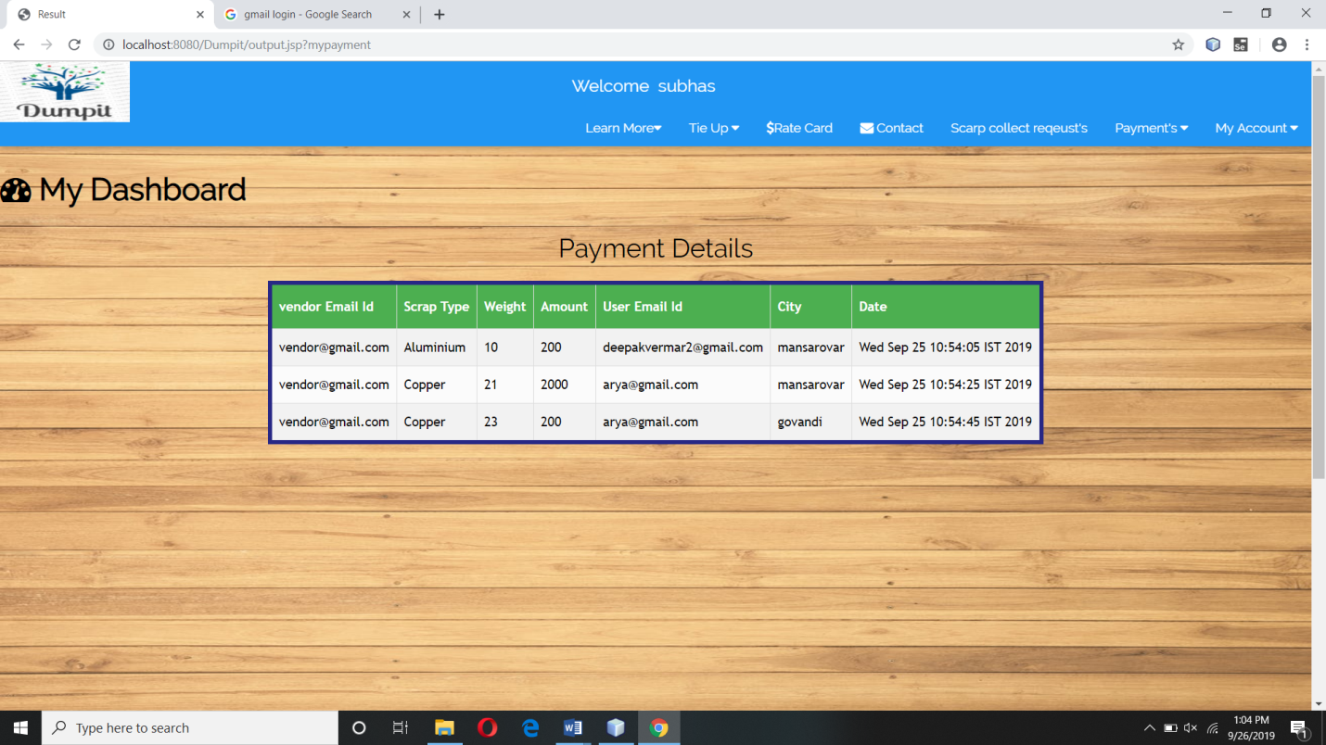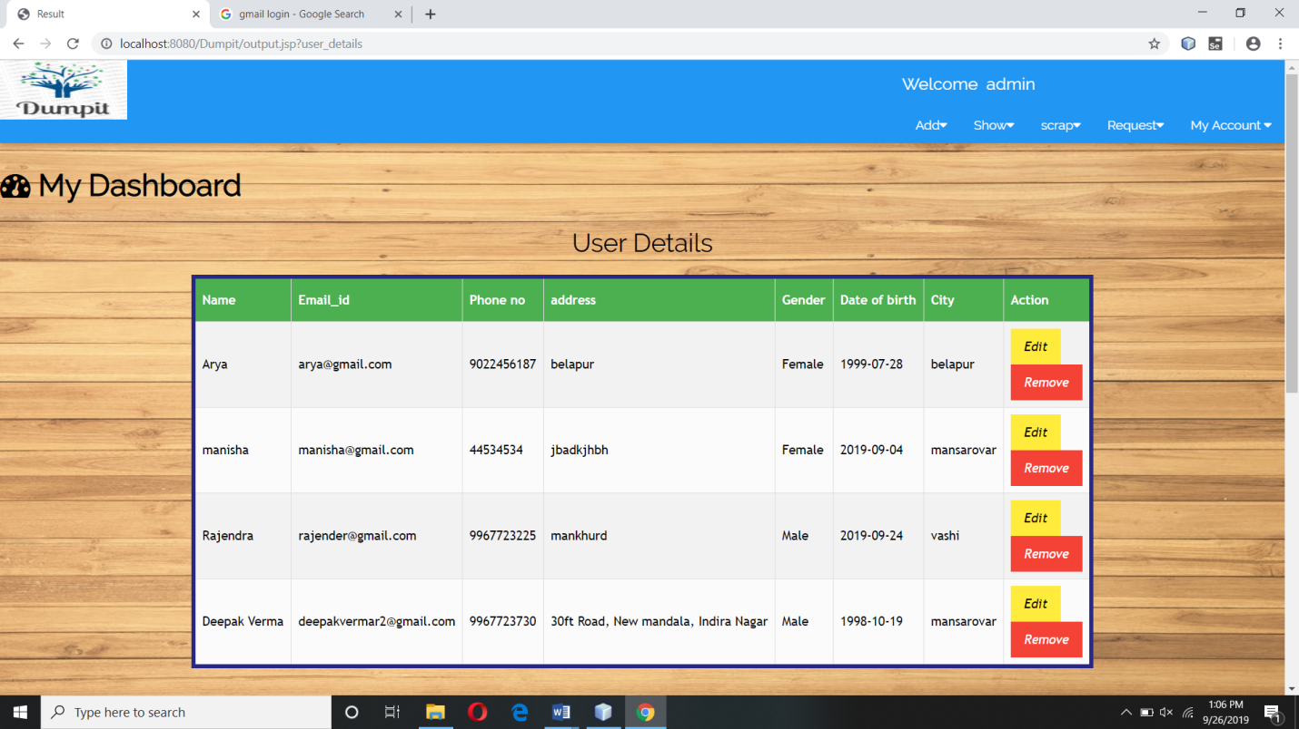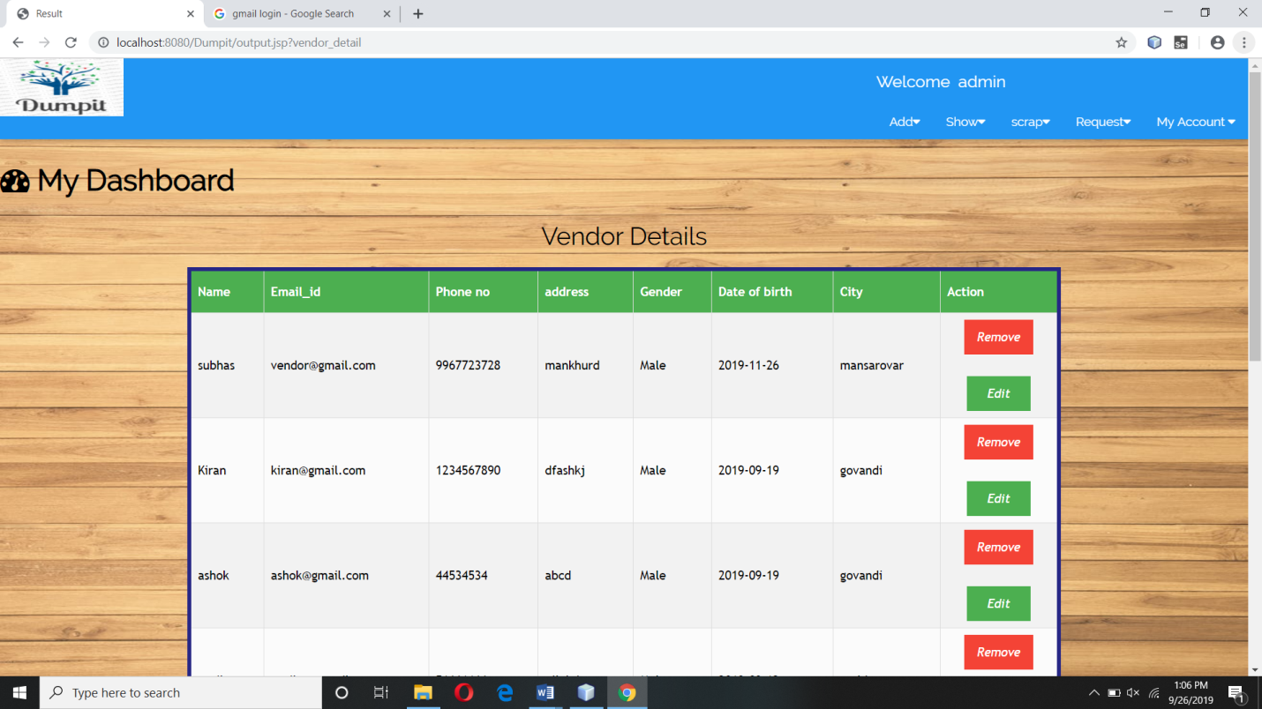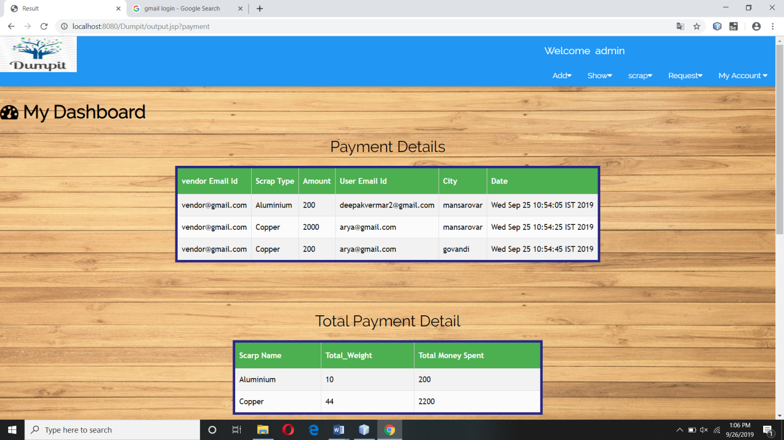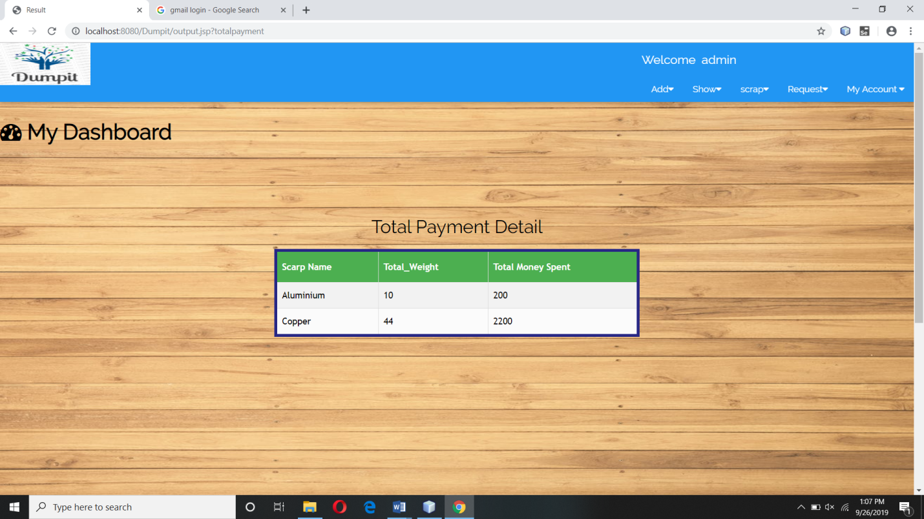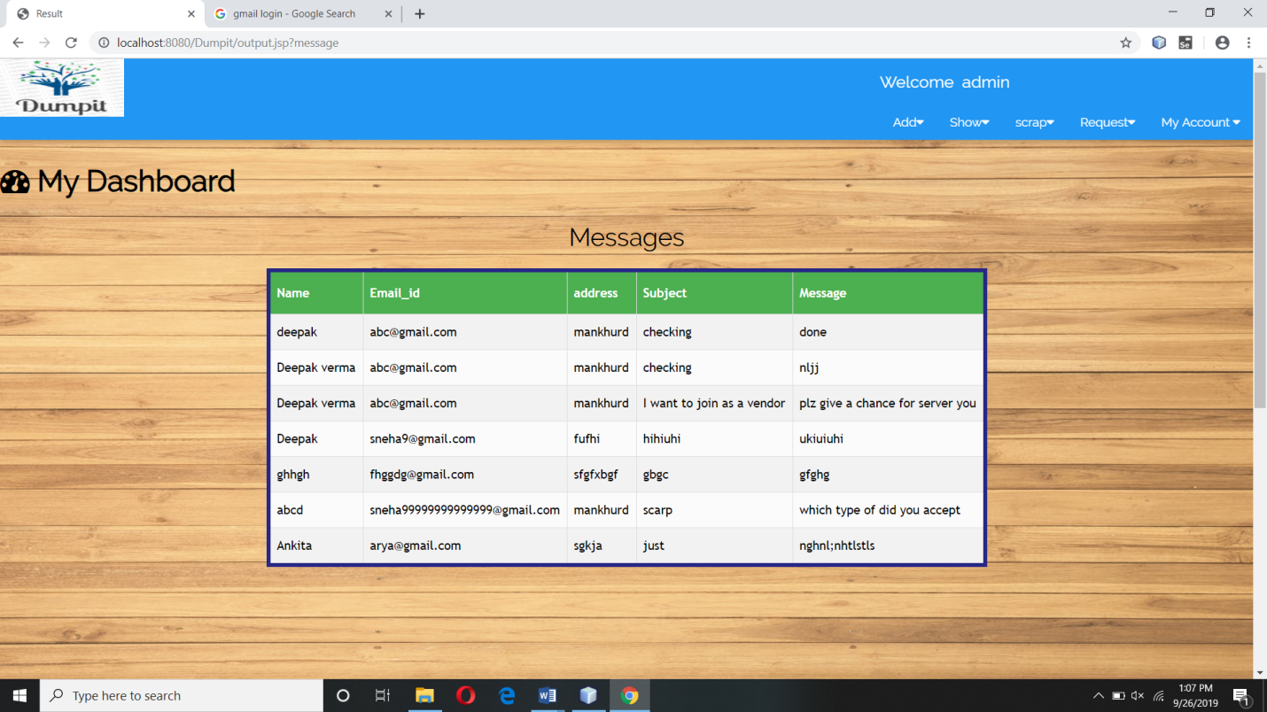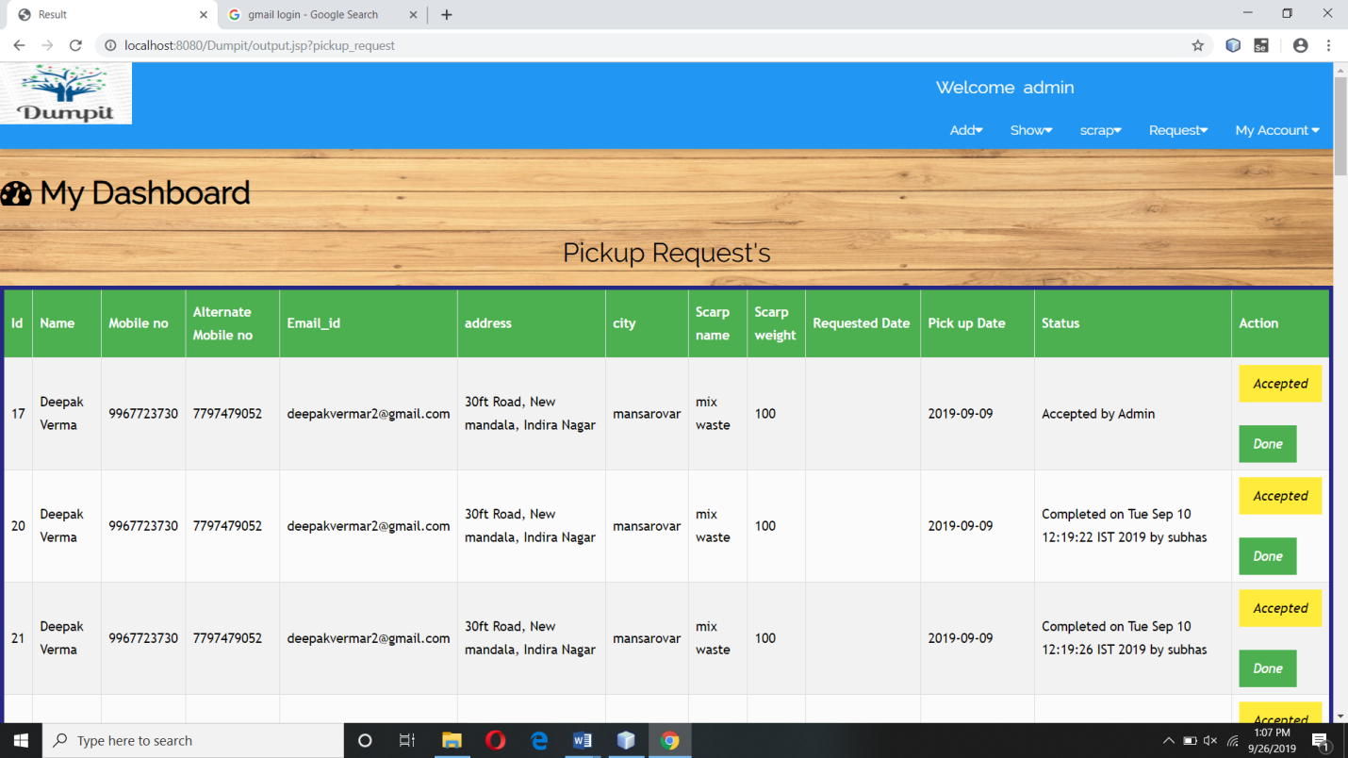

References and Bibliography

**•**Survey

•Scarp Dealer

•www.google.com

•www.youtube.com

• http://stackoverflow.com

• www.w3schools.com

• http://www.easywayserver.com/jsp/JSP-file-handling.html